Artificial Intelligence and Data Analytics focused on Green Skills Internship
AI-Powered Rooftop Detection and Green Infrastructure Analysis


Sl. No. | Reg. No. | Student Name | Department
1. | 23ETAI410027 | MONISHA S | CSE

Academic Supervisor: Ms. Nidhiben Divyesh Soni
Industrial Supervisor: Nagesh Singh
Place of Work: Edunet Foundation,AICTE, Shell India

B-TECH 2024
FACULTY OF ENGINEERING AND TECHNOLOGY
M.S. Ramaiah University of Applied Sciences


Faculty of Engineering and Technology
Certificate

This is to certify that the Internship Report “ AI-Powered Rooftop Detection and Green Infrastructure Analysis” is a bona-fide work carried out in the Department of Computer Science Engineering by Monisha S (23ETAI410027) in partial fulfilment of requirements for the award of B. Tech. Degree in Computer Science Engineering of M.S. Ramaiah University of Applied Sciences.

May – 2026
Ms. Nidhiben Divyesh Soni
Assistant Professor-Dept. of CSE
Coordinator

Declaration

The Internship Report is submitted in partial fulfilment of academic requirements for the B.Tech in Computer Science and Engineering Degree of M.S. Ramaiah University of Applied Sciences in the Department of-(CS/IS/AIML/MC), Faculty of Engineering. This Internship Report is a result of my own research / study. All sections of the text and results, which have been obtained from other sources, are fully referenced.

Signature : 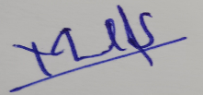
Name of the Student : Monisha S
Reg. No. : 23ETAI410027

Date : 25/05/2026

Internship Completion Certificate


Acknowledgements

I wish to express my sincere gratitude to my University Guide Ms. Nidhiben Divyesh Soni , for her guidance that has helped me tremendously at all times during my internship. Her immense knowledge, profound experience and professional expertise has enabled me to complete this Internship successfully.

My sincere gratitude to the Coordinator - Nidhiben Divyesh Soni at Ramaiah University of Applied Sciences, for valuable inputs.

I would also like to thank Dr. C Narendra Babu HOD – Faculty of Engineering, for his support and guidance and to the University for supporting all my endeavors.

Contents

Declaration by Student i
Internship Completion Certificate ii
Acknowledgements v
List of Figures if any viii
List of Tables if any ix
CHAPTER 1: Introduction and Motivation 01
CHAPTER 2: Skills Learned 18
CHAPTER 3: Project/Tasks Done 22
CHAPTER 4: Tools and Technologies Used 26
CHAPTER 5: Challenges faced and Solution 32
CHAPTER 6: Conclusions and Take Aways 37
Experience 39
References 40

Page no’s to be updated

List of Figures

Figure 1.2: Key Milestones in the Evolution of E-commerce 11

Page no’s to be updated

List of Tables
Table 2.4 Research Studies on E-commerce and Digital Strategies 20
Table 3.4 E-commerce Objectives and Methods 23

Page no’s to be updated

Abbreviation and Acronyms

Abbreviation | Full Form
AI | Artificial Intelligence
UHI | Urban Heat Island
UHSI | Urban Heat Stress Index
YOLO | You Only Look Once
YOLOv8 | You Only Look Once Version 8
LST | Land Surface Temperature
GIS | Geographic Information System
CNN | Convolutional Neural Network
ML | Machine Learning
DL | Deep Learning
GPU | Graphics Processing Unit
ROI | Region of Interest
OpenCV | Open Source Computer Vision Library
TIFF | Tagged Image File Format
GUI | Graphical User Interface
AICTE | All India Council for Technical Education
RGB | Red Green Blue
PNG | Portable Network Graphics
JPEG | Joint Photographic Experts Group
CV | Computer Vision

Chapter 1 : Introduction and Motivation

1.1 Introduction
The field of Artificial Intelligence, Computer Vision, and Remote Sensing has become important in solving environmental and urban problems. One of the major environmental issues in modern cities is the Urban Heat Island (UHI) effect, where urban areas experience higher temperatures than nearby rural regions. Rapid urbanization, increasing infrastructure, and reduction in vegetation are major reasons for this problem. Materials such as concrete and asphalt absorb and retain heat, which increases urban temperatures. Rooftops contribute significantly to heat accumulation because they are directly exposed to sunlight for long durations.
I am currently pursuing a Bachelor of Technology in Artificial Intelligence and Machine Learning at Ramaiah University of Applied Sciences, Bengaluru. As a sixth-semester student, I wanted to improve my practical knowledge in Artificial Intelligence, Deep Learning, and environmental analysis through a real-world project. While academic learning helped me understand theoretical concepts, this internship gave me an opportunity to apply those concepts practically.
This internship was carried out under Edunet Foundation from 27th October 2025 to 27th November 2025.
During the internship, I developed an AI-based Urban Heat Island rooftop analysis system using YOLOv8 segmentation and thermal mapping techniques. The system detects rooftops from satellite imagery, analyzes rooftop temperatures using thermal TIFF data, and visualizes the results through a Streamlit dashboard. The project helped me gain practical experience in Deep Learning, Computer Vision, satellite image processing, thermal analysis, and dashboard development while understanding how Artificial Intelligence can support sustainable urban planning and environmental monitoring.

1.2 Motivation for Choosing Urban Heat Island Rooftop Analysis
My motivation for choosing this internship came from my interest in Artificial Intelligence, Computer Vision, and environmental sustainability. As a student of Artificial Intelligence and Machine Learning, I wanted to work on a project that could solve a practical urban problem while improving my technical skills.
Urban Heat Island effects are increasing in many cities because of rapid infrastructure development and decreasing vegetation cover. Rising temperatures affect energy consumption, environmental conditions, and public health. I became interested in studying how rooftops contribute to urban heat accumulation and how Artificial Intelligence can be used to analyze rooftop heat patterns efficiently.
Another important motivation was to gain hands-on experience in Deep Learning and Remote Sensing technologies. Working on this project gave me an opportunity to use YOLOv8 segmentation, satellite image processing, thermal TIFF datasets, Land Surface Temperature analysis, and Streamlit dashboard development in a practical environment. Detecting rooftops and analyzing rooftop temperature distribution helped me understand the practical applications of AI in environmental analysis and smart city development.
The internship also helped me understand how technologies such as Artificial Intelligence, Computer Vision, and Geospatial Analysis can support climate monitoring and sustainable urban planning. It increased my interest in developing intelligent systems for environmental and urban analysis.

1.3 Internship Objectives
Before starting the internship, I set the following objectives for myself:
- To gain practical experience in Artificial Intelligence and Computer Vision through a real-world project.
- To learn technologies such as YOLOv8, satellite image processing, thermal TIFF analysis, and Streamlit dashboard development.
- To build a system that can automatically detect rooftops from satellite images and analyze rooftop temperature distribution.
- To understand the workflow of image annotation, model training, segmentation, and thermal analysis in AI-based applications.
- To explore how Artificial Intelligence can support urban planning and environmental monitoring.
I successfully achieved these objectives during the internship through the development of the Urban Heat Island rooftop analysis system.

1.4 Overview of the Urban Heat Island Rooftop Analysis System
The Urban Heat Island rooftop analysis system is an AI-based application developed to detect rooftops from satellite imagery and analyze rooftop heat distribution using thermal data. The system combines Artificial Intelligence, Computer Vision, Remote Sensing, and Data Visualization techniques.
The project consists of the following main components:
• Rooftop Detection and Segmentation
I used the YOLOv8 segmentation model to detect and segment rooftops from satellite images. The model was trained using annotated rooftop datasets to improve detection accuracy.
• Thermal Analysis
Thermal TIFF datasets and Land Surface Temperature (LST) data were used to analyze rooftop temperatures. The segmented rooftop regions were mapped with thermal data to study rooftop heat distribution.
• Dashboard and Visualization
I developed an interactive dashboard using Streamlit to display rooftop segmentation results, temperature values, thermal heatmaps, and rooftop analysis outputs.
• Data Processing
Satellite images and thermal datasets were processed using image processing and geospatial analysis techniques. Different modules were integrated into a single workflow for efficient rooftop analysis.
The system is modular and can be improved further for large-scale urban heat analysis and smart city applications.

1.5 Industry Relevance and Scope
Urban Heat Island analysis is becoming important in modern cities because of increasing temperatures and environmental concerns. Governments and urban planners are using Artificial Intelligence and Remote Sensing technologies for climate monitoring and sustainable urban planning.
AI-based rooftop thermal analysis systems can help identify heat-prone regions, improve urban planning, and support cooling strategies such as green roofs and solar rooftops. These systems reduce manual work and improve the efficiency of urban heat analysis.
The technologies used in this project, including Deep Learning, satellite image analysis, thermal mapping, and dashboard development, are widely used in industries related to Artificial Intelligence, Remote Sensing, Environmental Monitoring, and Smart City development.
The skills gained through this project are useful for real-world applications in climate analysis, geospatial technology, and intelligent urban management systems.

1.6 Structure of this Report
This report presents the complete internship work in a chapter-wise format.
- Chapter 2 explains the technical and practical skills gained during the internship.
- Chapter 3 describes the project development process and tasks completed during the internship.
- Chapter 4 discusses the tools and technologies used for rooftop segmentation, thermal analysis, and dashboard development.
- Chapter 5 explains the challenges faced during the project and the solutions implemented.
- Chapter 6 summarizes the learning outcomes, conclusions, and overall internship experience.
The report ends with references and future scope of the project.

Chapter 2 : Skills Learned
2.1 Technical Skills
The internship program conducted under AICTE, Shell India, and Edunet Foundation provided practical exposure to Artificial Intelligence, Computer Vision, Remote Sensing, and Dashboard Development through the Urban Heat Island rooftop analysis project. During the internship, I developed technical skills related to deep learning, satellite image processing, thermal analysis, and interactive visualization systems.

2.1.1 Computer Vision and Deep Learning
One of the major skills I gained during the internship was understanding Computer Vision and Deep Learning techniques for image analysis. I learned how deep learning models process satellite imagery to identify rooftops automatically. The internship provided practical exposure to object detection and image segmentation using YOLOv8 architecture.
I also learned the workflow involved in dataset preparation, annotation, model training, validation, and prediction generation using AI-based segmentation techniques.

2.1.2 YOLOv8 Segmentation
The internship helped me gain hands-on experience with YOLOv8 segmentation for rooftop detection. I learned how to train custom segmentation models using annotated satellite image datasets.
Skills gained include:
- Training YOLOv8 segmentation models
- Image preprocessing and augmentation
- Confidence threshold tuning
- Prediction and segmentation mask generation
- Performance evaluation and visualization
This improved my understanding of real-time object detection and segmentation systems.

2.1.3 Satellite Image Processing
I learned how satellite images can be collected and processed for urban analysis applications. Google Earth imagery was used for rooftop dataset creation and analysis.
The internship improved my understanding of:
- Satellite image acquisition
- Rooftop image extraction
- Image annotation workflows
- Urban feature identification
- Remote sensing applications
This provided practical exposure to geospatial data analysis and satellite imagery interpretation.

2.1.4 Thermal Analysis and Land Surface Temperature Mapping
One of the important skills I developed during the internship was thermal image analysis using Land Surface Temperature (LST) data.
I learned how thermal TIFF files can be processed using Rasterio and NumPy libraries to extract rooftop temperature values.
Skills gained include:
- Thermal image preprocessing
- Temperature extraction
- Heatmap generation
- Rooftop temperature analysis
- Urban Heat Island visualization
This helped me understand how thermal mapping techniques are used for environmental monitoring and urban climate analysis.

2.1.5 Dashboard Development with Streamlit
The internship also provided practical knowledge of dashboard development using Streamlit.
I learned how to create interactive dashboards capable of displaying:
- Rooftop segmentation outputs
- Thermal heatmaps
- Temperature distribution charts
- Rooftop statistics
- Interactive visualizations
The dashboard integrated AI predictions with graphical analytics, which improved my understanding of real-time visualization systems.

2.1.6 Data Visualization and Analytics
I developed skills in visualizing and interpreting data using Python visualization libraries such as Matplotlib and Pandas.
The internship improved my understanding of:
- Histogram generation
- Pie chart visualization
- Heatmap visualization
- Statistical analysis
- Dashboard-based analytics
This helped me present complex thermal analysis results in a simple and understandable manner.

2.1.7 Dataset Annotation and Preparation
I gained practical experience in preparing custom datasets for deep learning applications.
Using Roboflow annotation tools, I learned:
- Image annotation
- Segmentation mask creation
- Dataset organization
- Dataset preprocessing
- Training and validation splitting
This improved my understanding of the importance of quality datasets in Artificial Intelligence projects.

2.1.8 Python Programming and Libraries
The internship strengthened my Python programming skills through the implementation of AI and visualization workflows.
I gained hands-on experience using libraries such as:
- OpenCV
- NumPy
- Pandas
- Matplotlib
- Rasterio
- Ultralytics YOLOv8
- Streamlit
This improved my ability to build complete AI-based analytical systems using Python.

2.2 Soft Skills and Professional Development
Apart from technical skills, the internship also improved several professional and interpersonal skills.
Working on a real-world AI and thermal analysis project strengthened my:
- Problem-solving abilities
- Analytical thinking
- Research skills
- Time management
- Technical documentation skills
I also improved my communication and presentation skills through project discussions, dashboard demonstrations, and report preparation.
The internship helped me understand industry-level AI workflows and increased my confidence in independently developing practical Artificial Intelligence solutions for environmental and urban analysis applications.

Chapter 3 : Project/ Task done

3.1 Project: Urban Heat Rooftop Analysis Using AI and Thermal Mapping
The main project completed during the internship was the development of an AI-based rooftop analysis system for studying Urban Heat Island effects using satellite imagery and thermal mapping techniques.
The system was designed to automatically detect rooftops from satellite images, analyze rooftop heat distribution, and display thermal patterns through an interactive dashboard.
The project was developed using YOLOv8 segmentation for rooftop detection, Python-based thermal analysis for temperature extraction, and Streamlit for visualization.
The application combines Artificial Intelligence, Computer Vision, Remote Sensing, and Data Visualization techniques to support urban planning and environmental analysis.
The system allows users to:
- Upload satellite images
- Detect rooftops automatically
- Analyze rooftop heat intensity
- Visualize rooftop temperature distribution
- Study Urban Heat Island patterns

3.2 System Architecture
The Urban Heat Island analysis system follows an AI-based architecture consisting of four main layers:
• Dataset and Image Collection Layer
Satellite rooftop images were collected from Google Earth and prepared for segmentation training. Thermal TIFF files containing Land Surface Temperature (LST) data were used for thermal analysis.
• AI Segmentation Layer
YOLOv8 segmentation architecture was used for rooftop detection and segmentation. The trained model identifies rooftops and generates segmentation masks automatically.
• Thermal Analysis Layer
Thermal TIFF images were processed using Rasterio, NumPy, and OpenCV libraries to extract rooftop temperature values and generate heatmaps.
• Dashboard Visualization Layer
A Streamlit-based dashboard was developed to display rooftop segmentation results, thermal heatmaps, rooftop statistics, and temperature distribution charts.
This modular architecture improves scalability, visualization, and real-time analysis capability.

3.3 Implementation Details
3.3.1 Rooftop Dataset Collection and Annotation
The project started with collecting rooftop satellite images from urban regions in Bangalore using Google Earth.
The rooftop images were manually annotated using Roboflow segmentation tools. Polygon masks were created around rooftops to prepare the dataset for YOLOv8 segmentation training.
The dataset was divided into:
- Training dataset
- Validation dataset
- Testing dataset
Image preprocessing and augmentation techniques were applied to improve model performance.

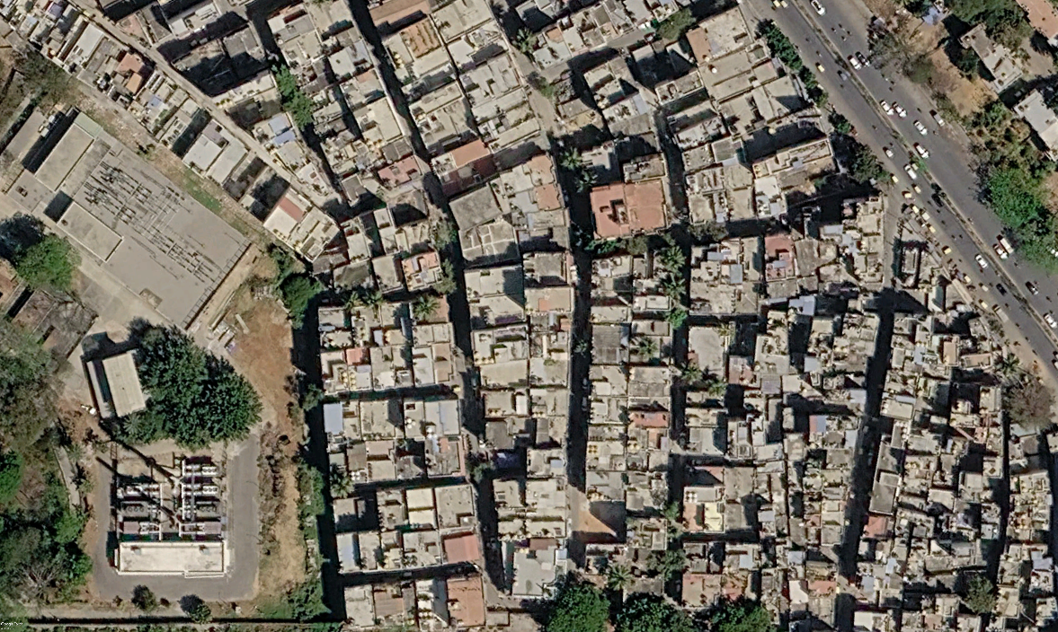
Figure 1: Original Satellite Rooftop Image Used for Analysis
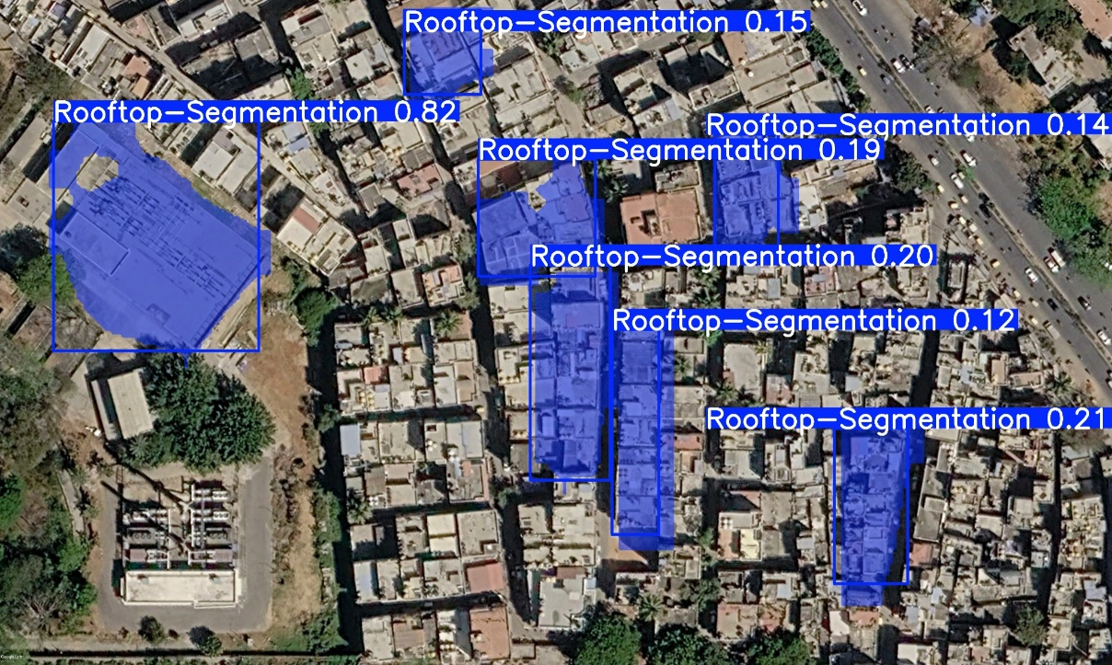
Figure 2: YOLOv8 Rooftop Segmentation Output

3.3.2 YOLOv8 Rooftop Segmentation Model
The rooftop segmentation model was developed using YOLOv8 segmentation architecture.
The model was trained on annotated rooftop datasets using Google Colab with GPU acceleration.
Training parameters included:

Parameter | Value
Epochs | 50
Image Size | 640 × 640
Batch Size | 8
Confidence Threshold | 0.10
Table 1: YOLOv8 Model Training Parameters
The model successfully learned rooftop boundaries and segmentation masks from satellite imagery.
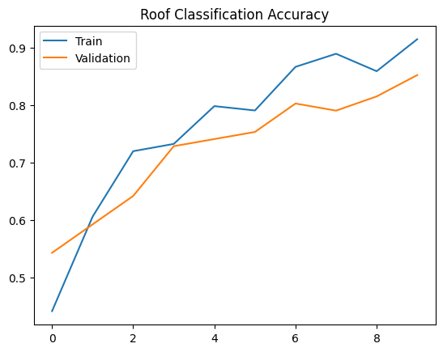
Figure 3: Training and Validation Accuracy of Roof Classification Model
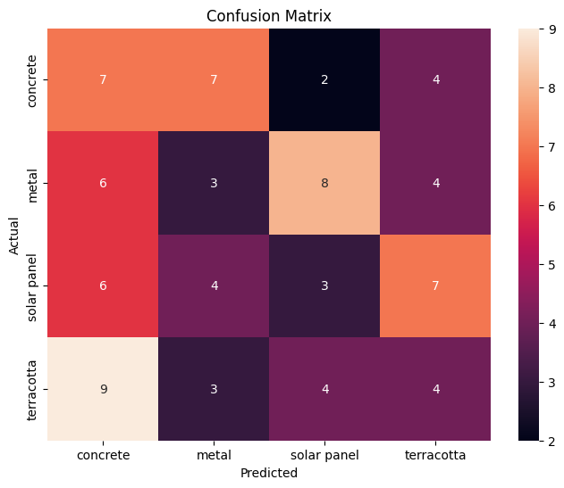
Figure 4: Confusion Matrix of Roof Type Classification Model

Roof Type | Precision | Recall | F1-Score | Support
Concrete | 0.25 | 0.35 | 0.29 | 20
Metal | 0.18 | 0.14 | 0.16 | 21
Solar Panel | 0.18 | 0.15 | 0.16 | 20
Terracotta | 0.21 | 0.20 | 0.21 | 20
Table 2:Performance Metrics of Roof Classification Model

3.3.3 Rooftop Prediction and Segmentation
After training, the YOLOv8 model was used to perform rooftop prediction on unseen satellite images.
The system generated segmentation masks and rooftop detection outputs with confidence scores.
The segmentation process automatically identifies rooftop regions from uploaded images.
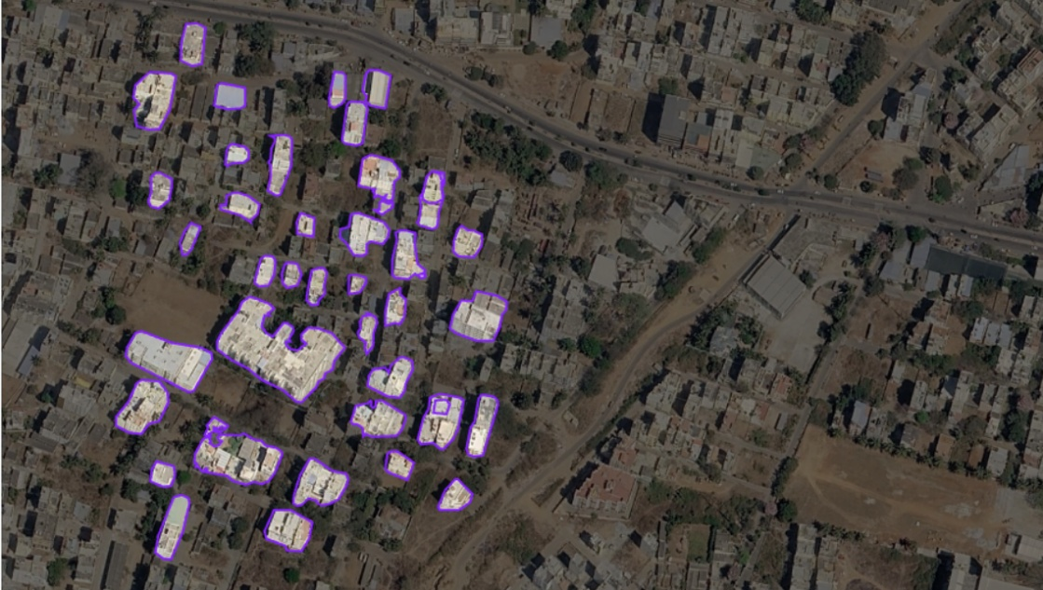
Figure 5: Rooftop Segmentation Mask Output
3.3.4 Thermal Analysis and Temperature Extraction
Land Surface Temperature (LST) TIFF files were used for rooftop thermal analysis.
Thermal images were processed using Rasterio and NumPy libraries to extract rooftop temperature values from detected rooftop regions.
The rooftops were categorized into:
- Cool rooftops
- Medium rooftops
- Hot rooftops
Heatmaps were generated to visualize temperature concentration zones.
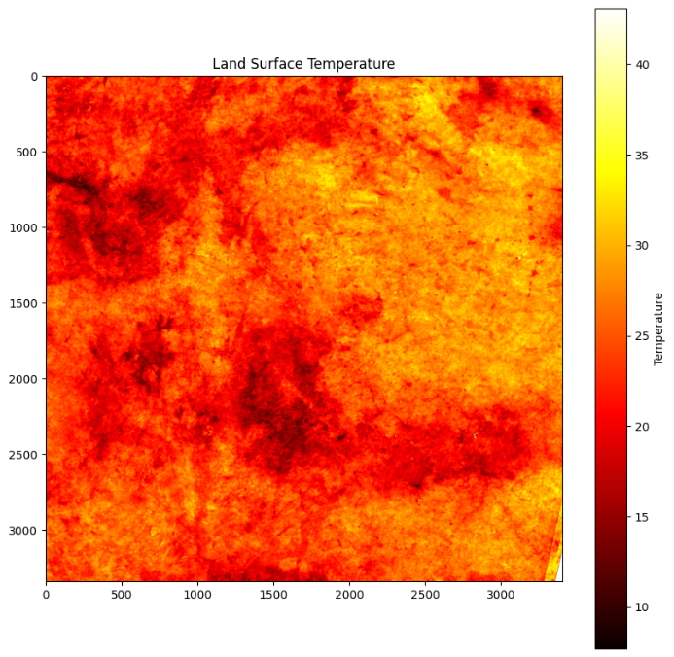
Figure 6: Thermal Distribution Map of Urban Region
3.3.5 Interactive Dashboard Development
An interactive Streamlit dashboard was developed for real-time visualization and analysis.
The dashboard allows users to:
- Upload satellite images
- View rooftop segmentation outputs
- Analyze rooftop temperatures
- Visualize heat distribution
- View rooftop statistics and charts
The dashboard integrates AI predictions with thermal analytics and graphical visualization.
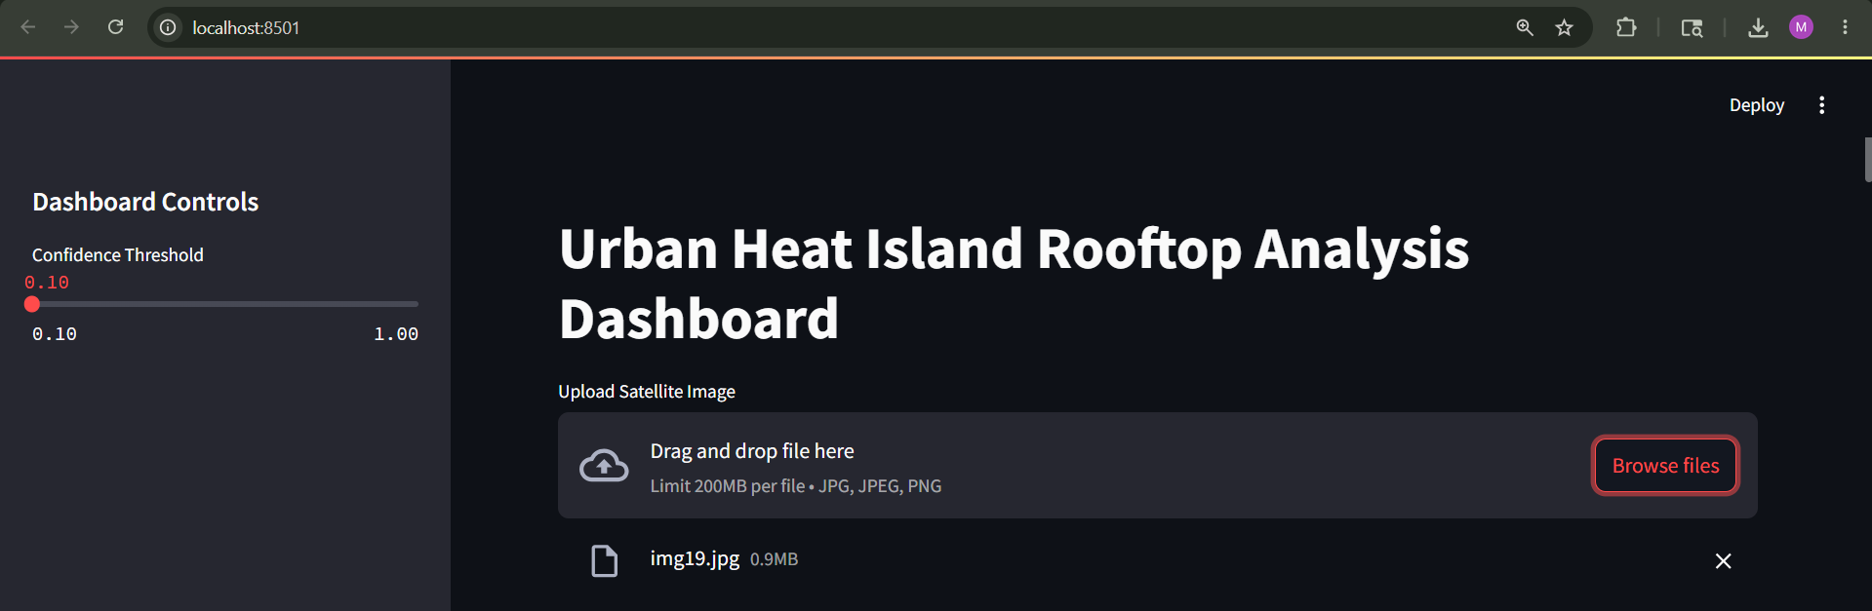
Figure 7: Urban Heat Island Rooftop Analysis Dashboard Interface
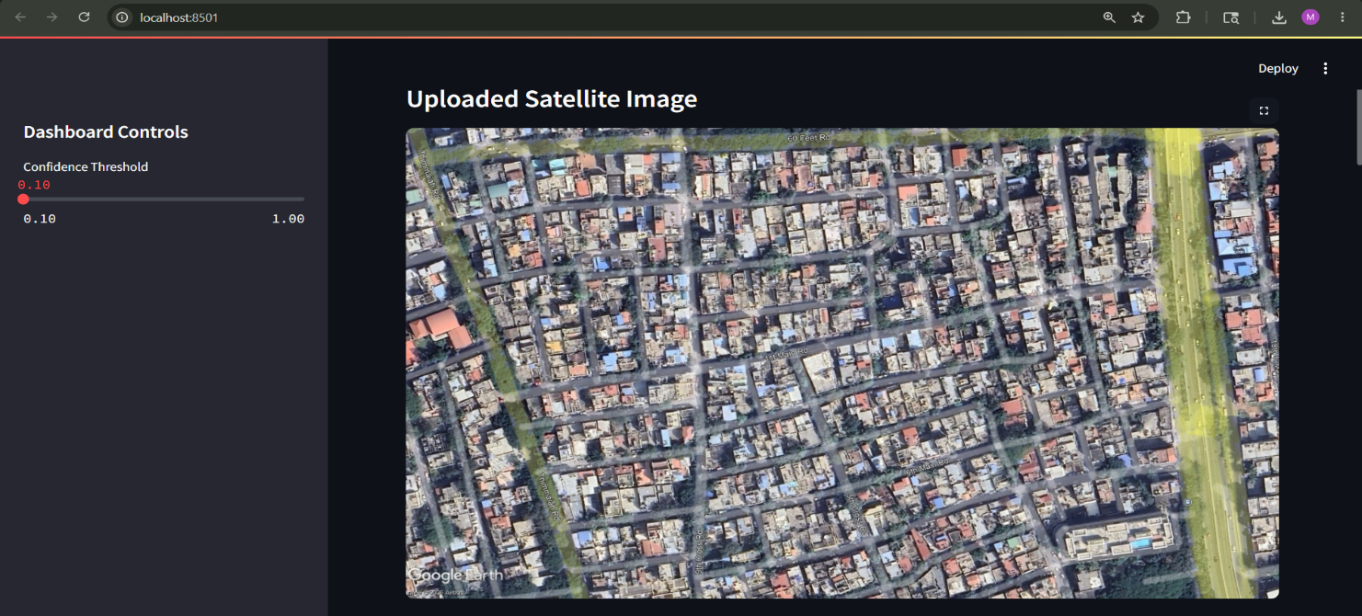
Figure 8: Input Satellite Image for Rooftop Detection

3.4 Results and Observations
The Urban Heat Island rooftop analysis system operated successfully and generated rooftop segmentation and thermal analysis outputs.
The YOLOv8 model accurately detected rooftops from satellite images and produced segmentation masks with good confidence levels.
The thermal analysis module successfully extracted rooftop temperature values and identified heat-prone rooftop regions.
The Streamlit dashboard provided interactive visualization of:
- Rooftop segmentation
- Temperature statistics
- Heat distribution graphs
- Thermal heatmaps
The results showed how Artificial Intelligence and Remote Sensing techniques can be combined for Urban Heat Island analysis and urban planning applications.
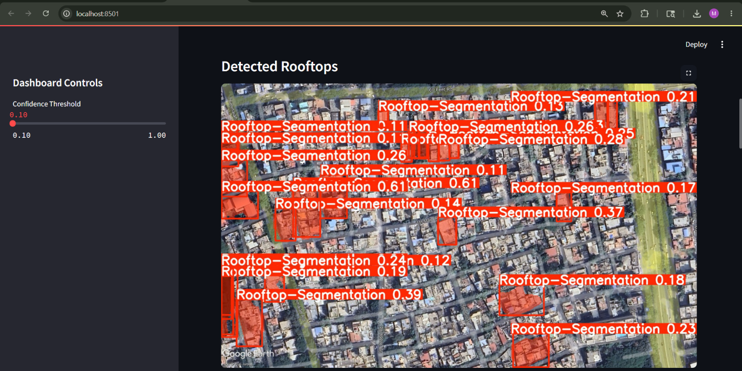
Figure 9: YOLO-Based Rooftop Segmentation Results

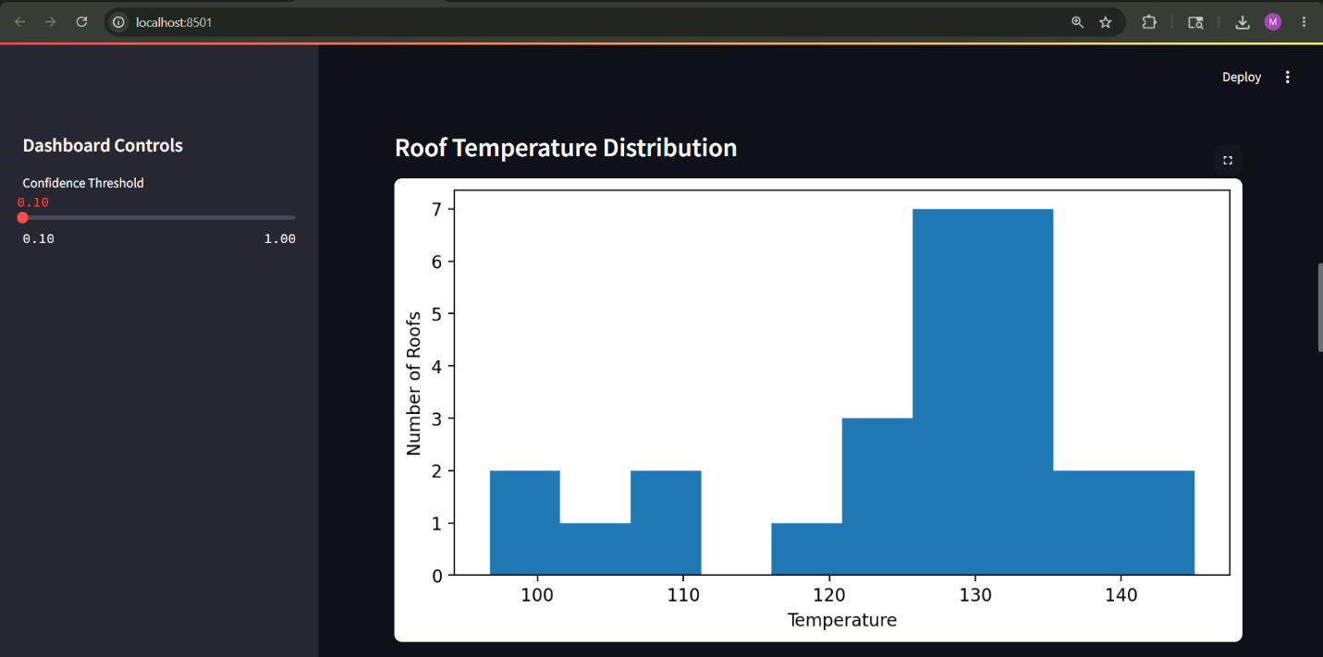
Figure 10: Histogram of Rooftop Temperature Distribution

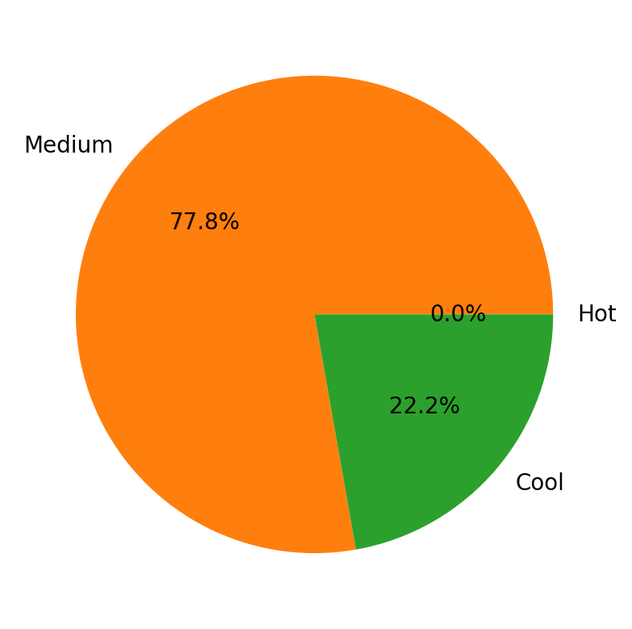
Figure 11: Rooftop Temperature Category Distribution

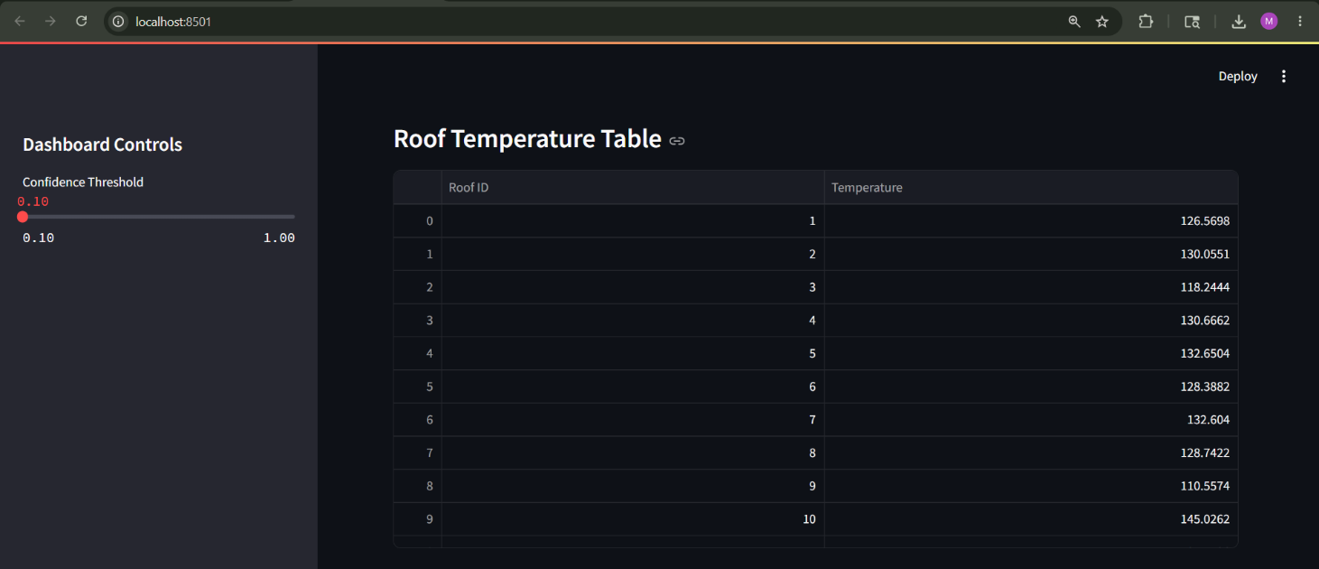
Figure 12: Rooftop Temperature Analysis Table
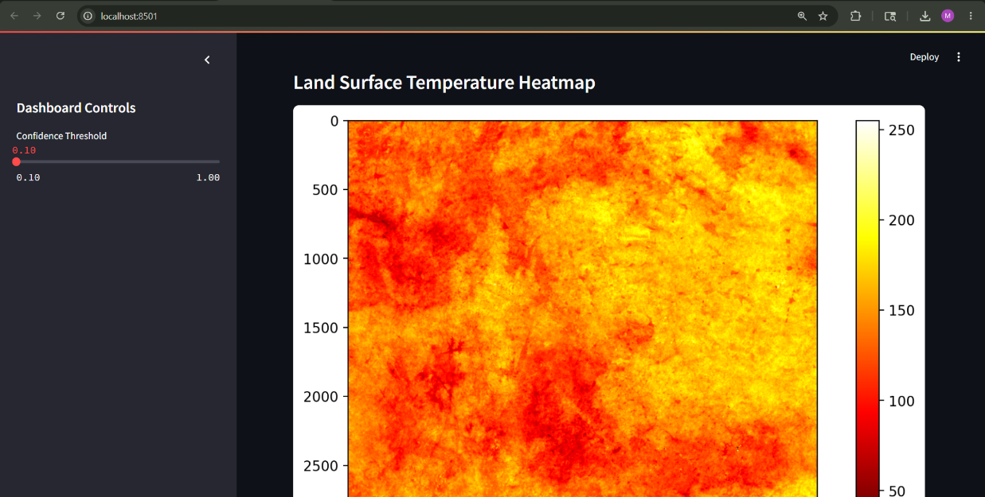
Figure 13: Land Surface Temperature (LST) Heatmap

Chapter 4 : Tools and Technologies Used

4.1 Python
Python was the main programming language used throughout the Urban Heat Island rooftop analysis project. I used Python for implementing deep learning models, image processing, thermal data analysis, and dashboard development. Working on the project improved my understanding of deep learning workflows, geospatial data processing, and scientific computing using Python libraries.

4.2 YOLOv8 Segmentation Model
YOLOv8 (You Only Look Once Version 8) was used as the main deep learning model for rooftop segmentation and detection. I trained the model using satellite image datasets to identify rooftops and generate segmentation masks with confidence scores. YOLOv8 provided fast and accurate object detection suitable for real-time urban analysis applications.

4.3 OpenCV
OpenCV was used for image preprocessing and visualization tasks. I used it for reading satellite images, converting image formats, resizing inputs, applying masks, and displaying segmented rooftop outputs. OpenCV also helped in integrating the segmentation model with the dashboard visualization.

4.4 NumPy and Pandas
NumPy was used for numerical computations and matrix operations during temperature extraction and image analysis. Pandas was used for organizing rooftop temperature values into structured tables for visualization and statistical analysis within the dashboard.

4.5 Matplotlib
Matplotlib was used to generate graphs and visualizations such as rooftop temperature histograms, pie charts, and Land Surface Temperature heatmaps. These visualizations helped in analyzing temperature distribution patterns across detected rooftops.

4.6 Streamlit
Streamlit was used to develop the interactive Urban Heat Island dashboard. It allowed users to upload satellite images, adjust confidence thresholds, visualize rooftop segmentation outputs, generate thermal graphs, and display rooftop temperature tables through a simple web interface.

4.7 Google Earth Engine
Google Earth Engine (GEE) was used for extracting and processing Land Surface Temperature (LST) data from satellite imagery. Thermal bands from Landsat datasets were processed to generate urban heatmaps and analyze temperature variations across Bangalore regions.

4.8 Landsat Satellite Data
Landsat satellite imagery was used as the main source of thermal and spatial data for the project. The thermal infrared bands were processed to calculate Land Surface Temperature values, which were later combined with rooftop segmentation results for Urban Heat Island analysis.

4.9 Google Colab and Kaggle
Google Colab and Kaggle were used as cloud-based development platforms for training the YOLOv8 segmentation model and performing large-scale image processing tasks. These platforms provided GPU support for faster model training and experimentation.

4.10 Visual Studio Code
Visual Studio Code (VS Code) was used as the main code editor for developing the Streamlit dashboard and managing project files. It provided debugging tools, extension support, and an efficient environment for Python-based application development.

4.11 Git and GitHub
Git and GitHub were used for version control and project management. They helped me track project changes, maintain backups, and organize the development workflow during the implementation of the rooftop analysis system.

4.12 Roboflow
Roboflow was used for dataset management, annotation handling, preprocessing, and exporting rooftop segmentation datasets in YOLO-compatible format. It simplified dataset preparation and improved the efficiency of the model training process.

CHAPTER 5 : Challenges Faced and Solutions

5.1 Rooftop Dataset Collection and Annotation
One of the main challenges during the project was collecting suitable rooftop satellite image datasets for segmentation and classification. Publicly available datasets were limited, and many images contained unclear rooftops, shadows, or low-resolution areas that affected model training performance.
I addressed this challenge by using Roboflow for dataset preprocessing, annotation management, and augmentation. Multiple rooftop samples were collected and organized into training, validation, and testing datasets to improve model learning and segmentation accuracy.

5.2 YOLOv8 Model Training Challenges
During the initial stages of training the YOLOv8 segmentation model, the model produced low-confidence detections and inaccurate rooftop boundaries. In some cases, the model failed to detect smaller rooftops and incorrectly segmented nearby objects such as roads and open spaces.
I solved this issue by increasing the number of training epochs, adjusting confidence thresholds, resizing input images correctly, and improving annotation quality. Dataset augmentation and repeated training iterations helped improve rooftop segmentation performance.

5.3 Thermal Data Processing and LST Extraction
Extracting Land Surface Temperature (LST) values from Landsat thermal imagery was another challenge during the project. Initially, incorrect scaling formulas and band selection issues generated unrealistic temperature outputs during analysis.
I resolved this problem by correctly applying thermal conversion formulas in Google Earth Engine and validating the temperature ranges using reference values. This helped generate accurate thermal heatmaps for Urban Heat Island analysis.

5.4 Integration of Rooftop Segmentation with Thermal Analysis
Combining rooftop segmentation outputs with thermal imagery required synchronization between RGB satellite images and temperature data. Misalignment between segmented rooftops and thermal maps initially caused incorrect rooftop temperature calculations.
I addressed this issue by aligning image dimensions properly, normalizing image coordinates, and accurately mapping rooftop regions onto the thermal raster data. The final system successfully extracted rooftop-specific temperature values.

5.5 Streamlit Dashboard Development
Developing the interactive Streamlit dashboard involved several technical challenges, especially while integrating image uploads, model inference, thermal visualization, and graph generation into a single interface. Runtime errors occurred because of incompatible image formats and large image processing operations.
These issues were resolved by implementing image preprocessing techniques, converting images into compatible RGB formats, and optimizing the prediction workflow. Streamlit components were organized properly to provide smooth visualization and interaction within the dashboard.

5.6 Model Prediction and Runtime Errors
During deployment, several runtime errors occurred related to PyTorch dependencies, file paths, and image channel mismatches. Some uploaded satellite images contained four channels instead of three, which caused the YOLO model to fail during prediction.
I solved this issue by converting images from RGBA to RGB format before inference and properly configuring model paths and dependencies within the Python environment. Additional debugging improved the stability of the application.

5.7 Performance Optimization and Visualization
Generating heatmaps, segmentation masks, histograms, and temperature tables for large satellite images required high computational resources. Processing delays occurred during real-time visualization in the dashboard.
I addressed this challenge by resizing input images, optimizing NumPy operations, and reducing unnecessary processing steps. Visualization performance improved after implementing efficient image handling techniques.

5.8 Balancing Internship Work and Academic Activities
Managing the internship project along with academic coursework and report preparation was challenging, especially during model training, debugging, and dashboard development stages. Maintaining project consistency while handling academic responsibilities required proper scheduling and planning.
I managed this challenge by following a structured workflow, setting daily development goals, and allocating separate time for coding, testing, documentation, and academic tasks. This experience improved my time management, problem-solving, and multitasking abilities.

CHAPTER 6 : Conclusion and Takeaways

6.1 Conclusion
The Urban Heat Island Rooftop Analysis project was successfully developed to detect rooftops from satellite imagery and analyze rooftop temperature variations using thermal data. The system combined deep learning, remote sensing, and interactive visualization techniques to study urban heat patterns effectively.
The YOLOv8 segmentation model was trained to accurately detect rooftops from high-resolution satellite images, while Land Surface Temperature (LST) data extracted from Landsat thermal imagery was used to analyze temperature distribution across urban regions. The project successfully combined rooftop segmentation outputs with thermal heatmaps to identify temperature variations among rooftops.
I also developed an interactive Streamlit dashboard to visualize uploaded satellite images, rooftop segmentation results, rooftop temperature distributions, thermal heatmaps, and rooftop temperature statistics in real time. The dashboard provided a simple and user-friendly interface for performing Urban Heat Island analysis and rooftop thermal assessment.
The project helped demonstrate how Artificial Intelligence, Computer Vision, and Geospatial Analysis can be combined to develop smart urban monitoring solutions. The system can support the identification of heat-prone urban areas and assist in sustainable urban planning, rooftop cooling strategies, and environmental monitoring applications.

6.2 Key Takeaways
During the internship and project development process, I gained several technical and professional skills through practical implementation and problem-solving activities.
6.2.1 Practical Exposure to Deep Learning
The project provided hands-on experience in training and implementing deep learning models using YOLOv8 for rooftop segmentation tasks. I learned how object detection and image segmentation models work on real-world satellite imagery datasets.

6.2.2 Understanding of Remote Sensing and Thermal Analysis
The project improved my understanding of satellite imagery processing, thermal band analysis, and Land Surface Temperature extraction using Google Earth Engine and Landsat datasets. I learned how thermal data can be used for Urban Heat Island studies and environmental analysis.

6.2.3 Experience in Image Processing and Visualization
I gained practical knowledge in image preprocessing, segmentation visualization, heatmap generation, histogram plotting, and rooftop temperature analysis using OpenCV, NumPy, Pandas, and Matplotlib libraries.

6.2.4 Interactive Dashboard Development
Developing the Streamlit dashboard helped me understand how machine learning models can be integrated into interactive web-based applications. I learned how to handle image uploads, model inference, dynamic visualizations, and real-time analysis within a dashboard environment.

6.2.5 Problem Solving and Debugging Skills
The project involved handling runtime errors, dependency conflicts, image compatibility issues, and model integration challenges. Solving these issues improved my debugging abilities, analytical thinking, and troubleshooting skills.

6.2.6 Knowledge of Geospatial and Urban Analysis Applications
The project provided insight into how Artificial Intelligence and Geospatial technologies can be used in smart city applications, environmental monitoring, and urban planning solutions for sustainable development.

6.2.7 Professional and Time Management Skills
Managing model training, dashboard development, thermal analysis, testing, and report documentation along with academic activities improved my time management, project planning, and multitasking abilities.

References
- Joseph Redmon et al., “YOLO: You Only Look Once – Unified Real-Time Object Detection,” IEEE Conference on Computer Vision and Pattern Recognition (CVPR), 2016.
- Ultralytics YOLOv8 Documentation
https://docs.ultralytics.com
- Google Earth Engine Documentation
https://developers.google.com/earth-engine
- Landsat 8 Satellite Data Documentation, United States Geological Survey (USGS)
https://www.usgs.gov/landsat-missions
- Streamlit Documentation
https://docs.streamlit.io
- OpenCV Documentation
https://opencv.org
- Roboflow Documentation
https://roboflow.com
- NumPy Documentation
https://numpy.org
- Pandas Documentation
https://pandas.pydata.org
- Matplotlib Documentation
https://matplotlib.org
- Python Software Foundation, Python Documentation
https://www.python.org
- Goodfellow, Ian, Yoshua Bengio, and Aaron Courville, Deep Learning, MIT Press, 2016.

APPENDIX

CODE AND OUTPUT:
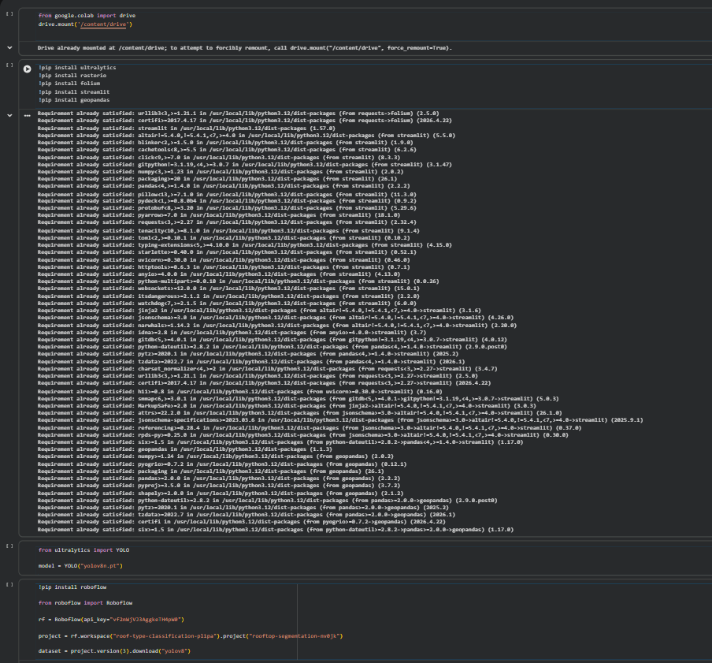
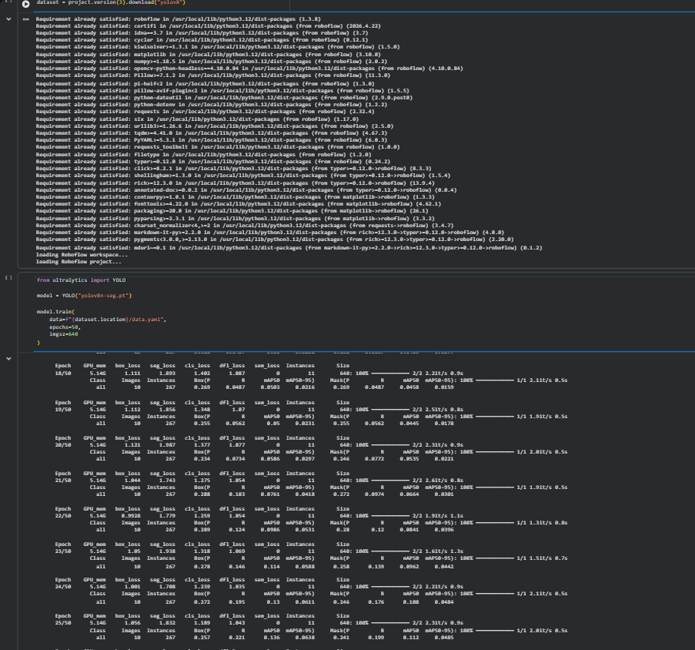
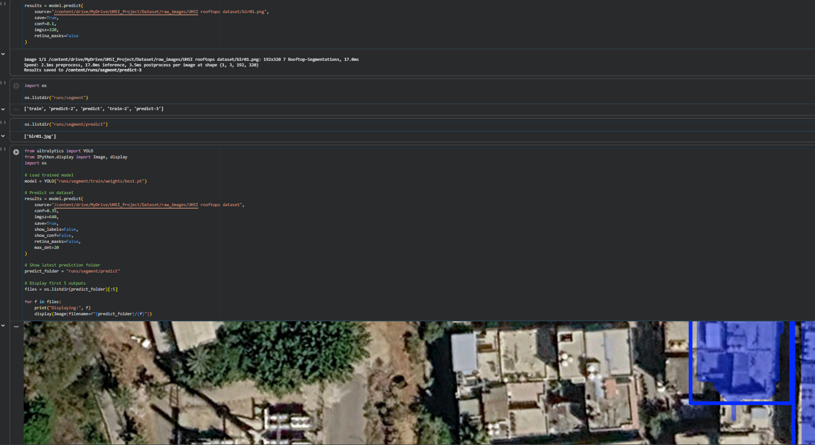
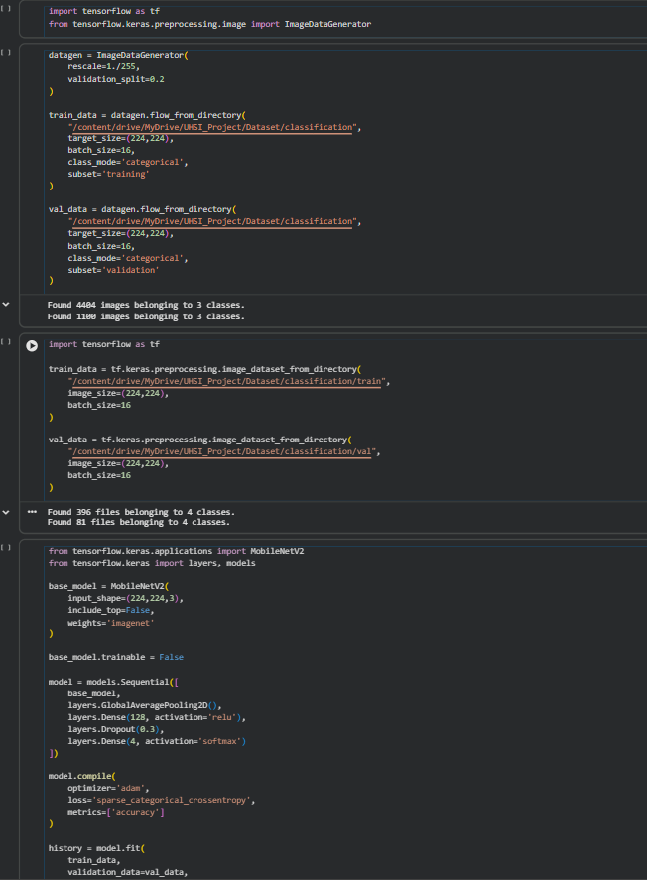
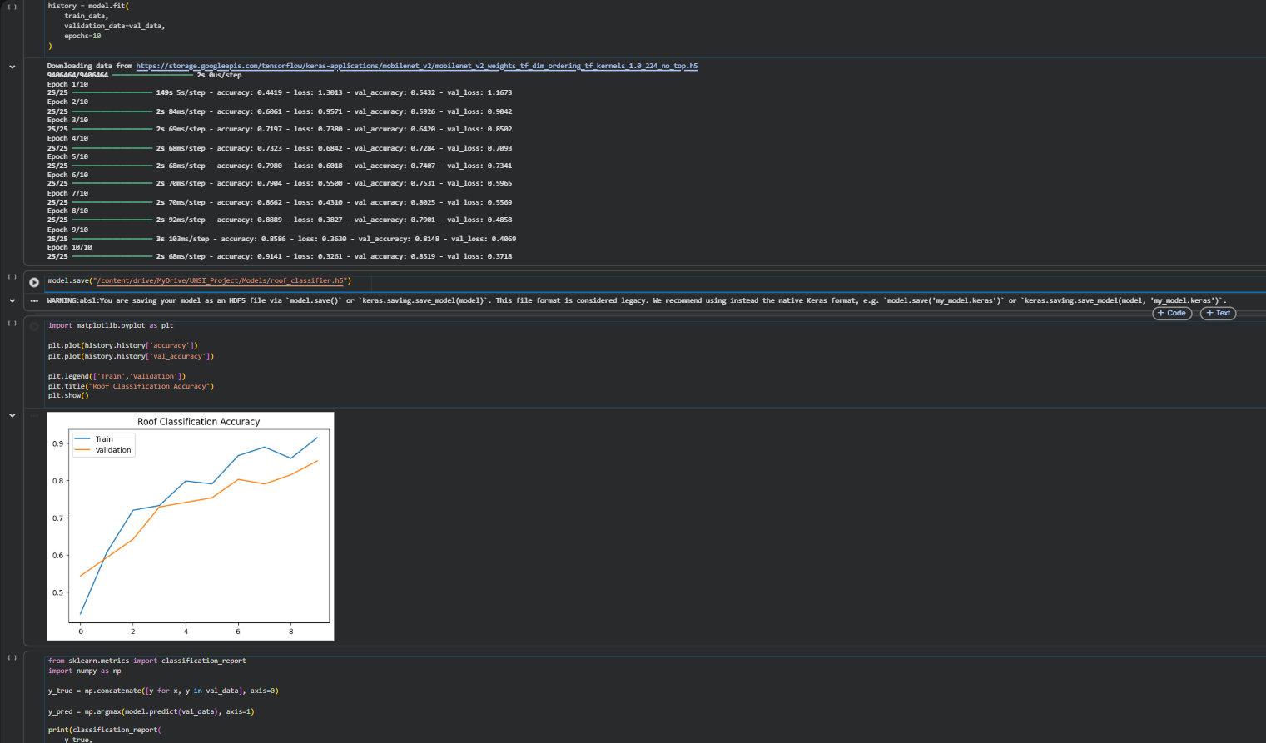
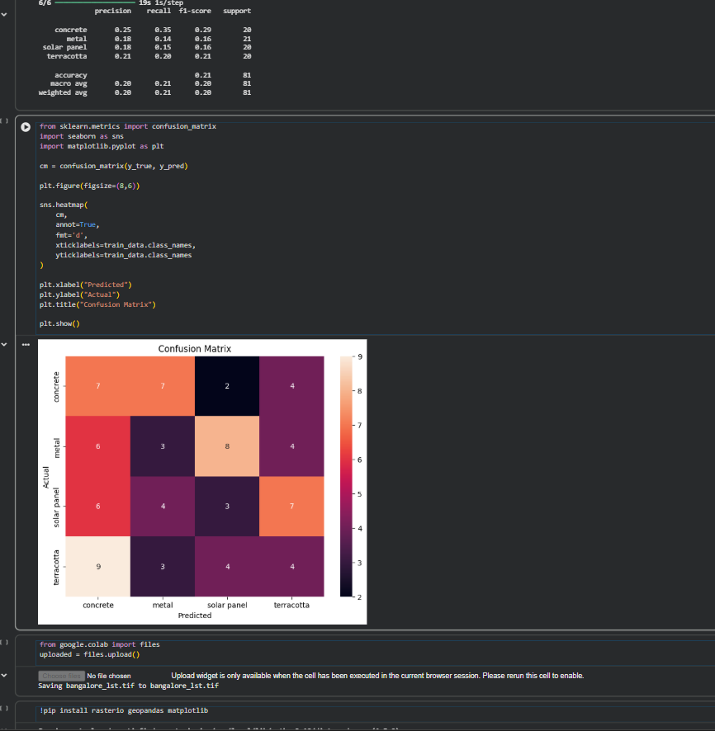
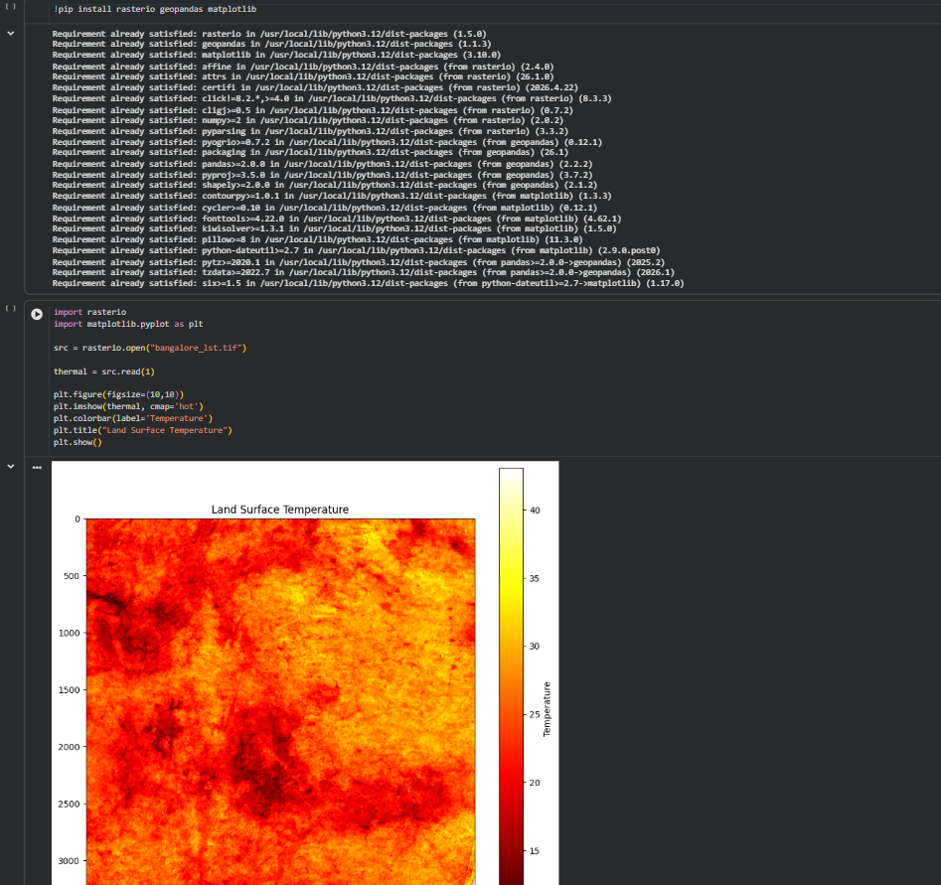
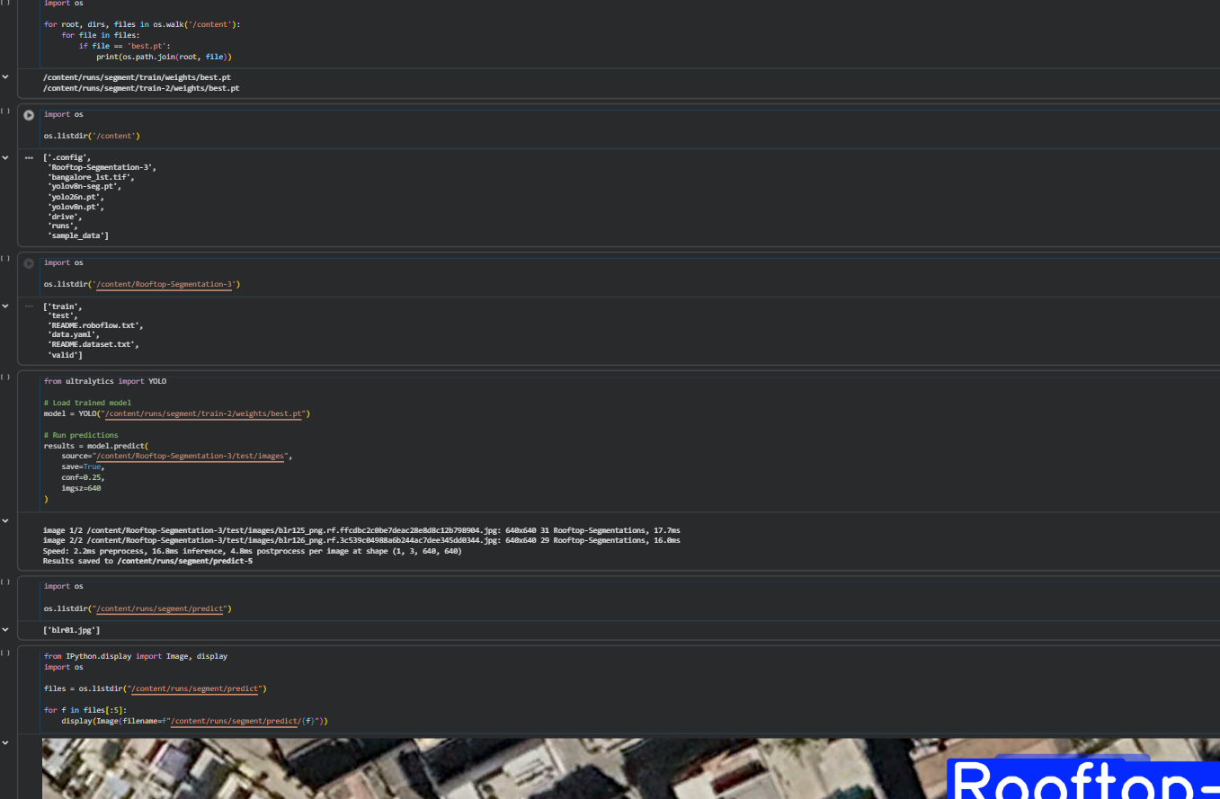

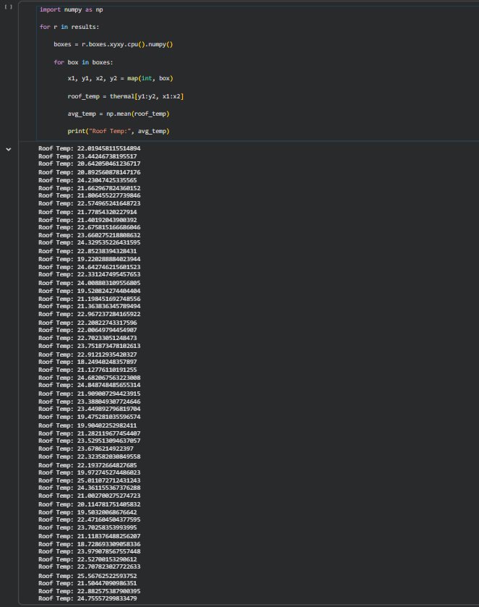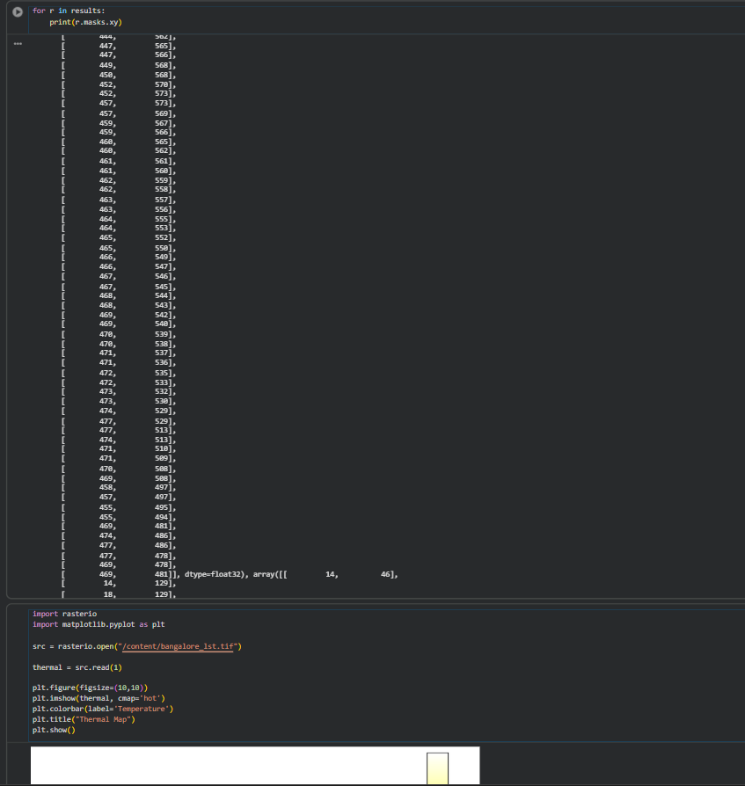
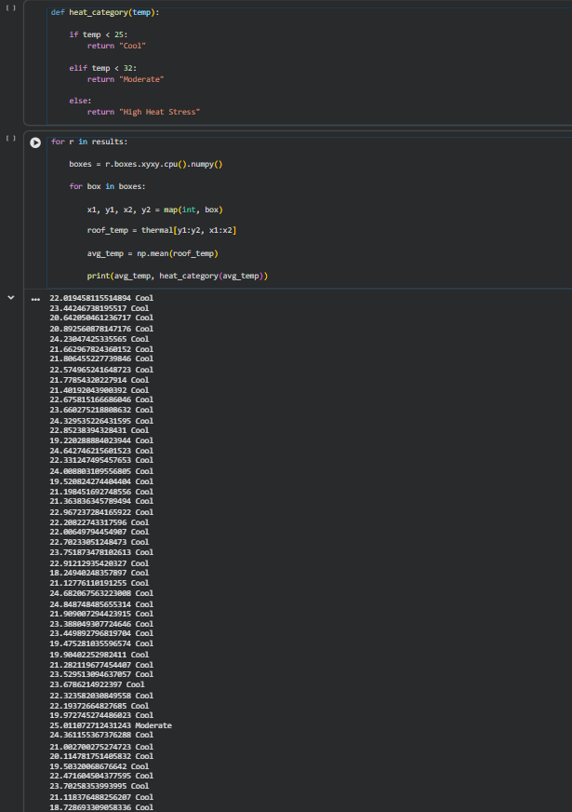
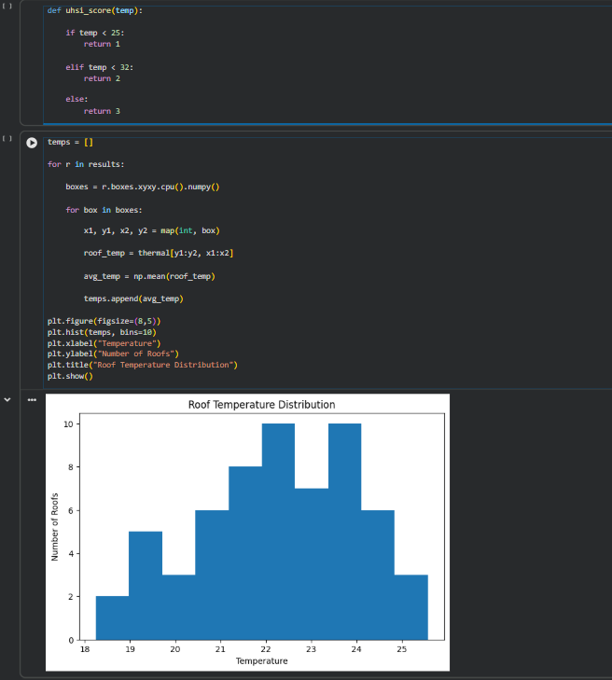
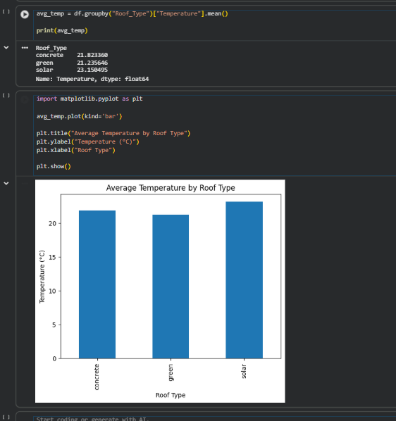

FOR INTERACTIVE VISUALISATION:
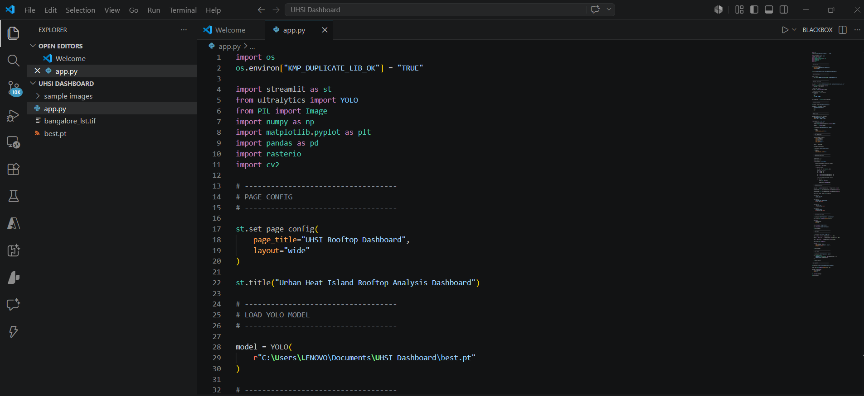
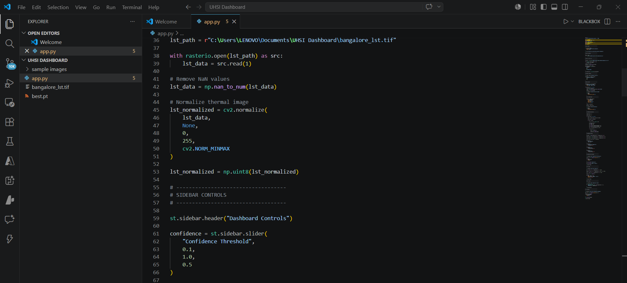
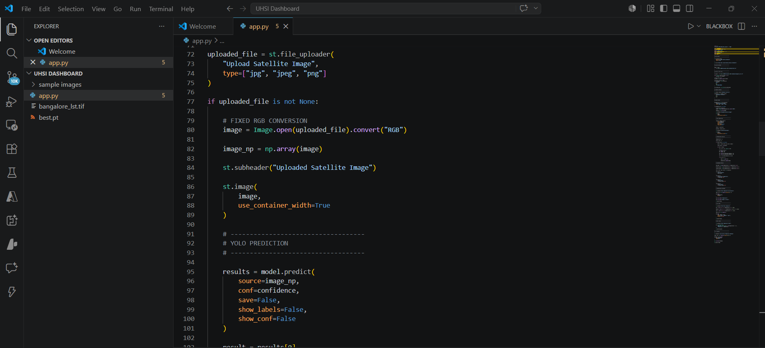
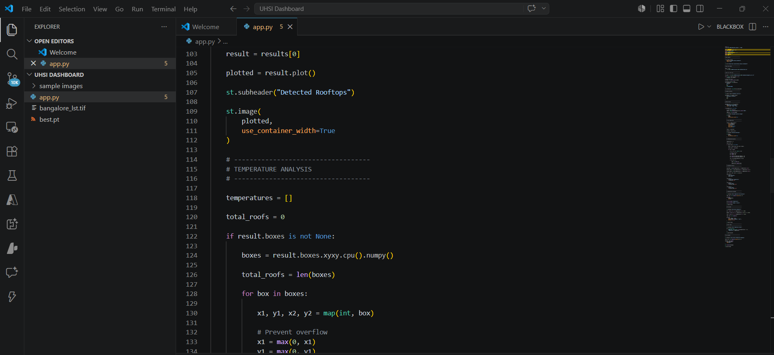
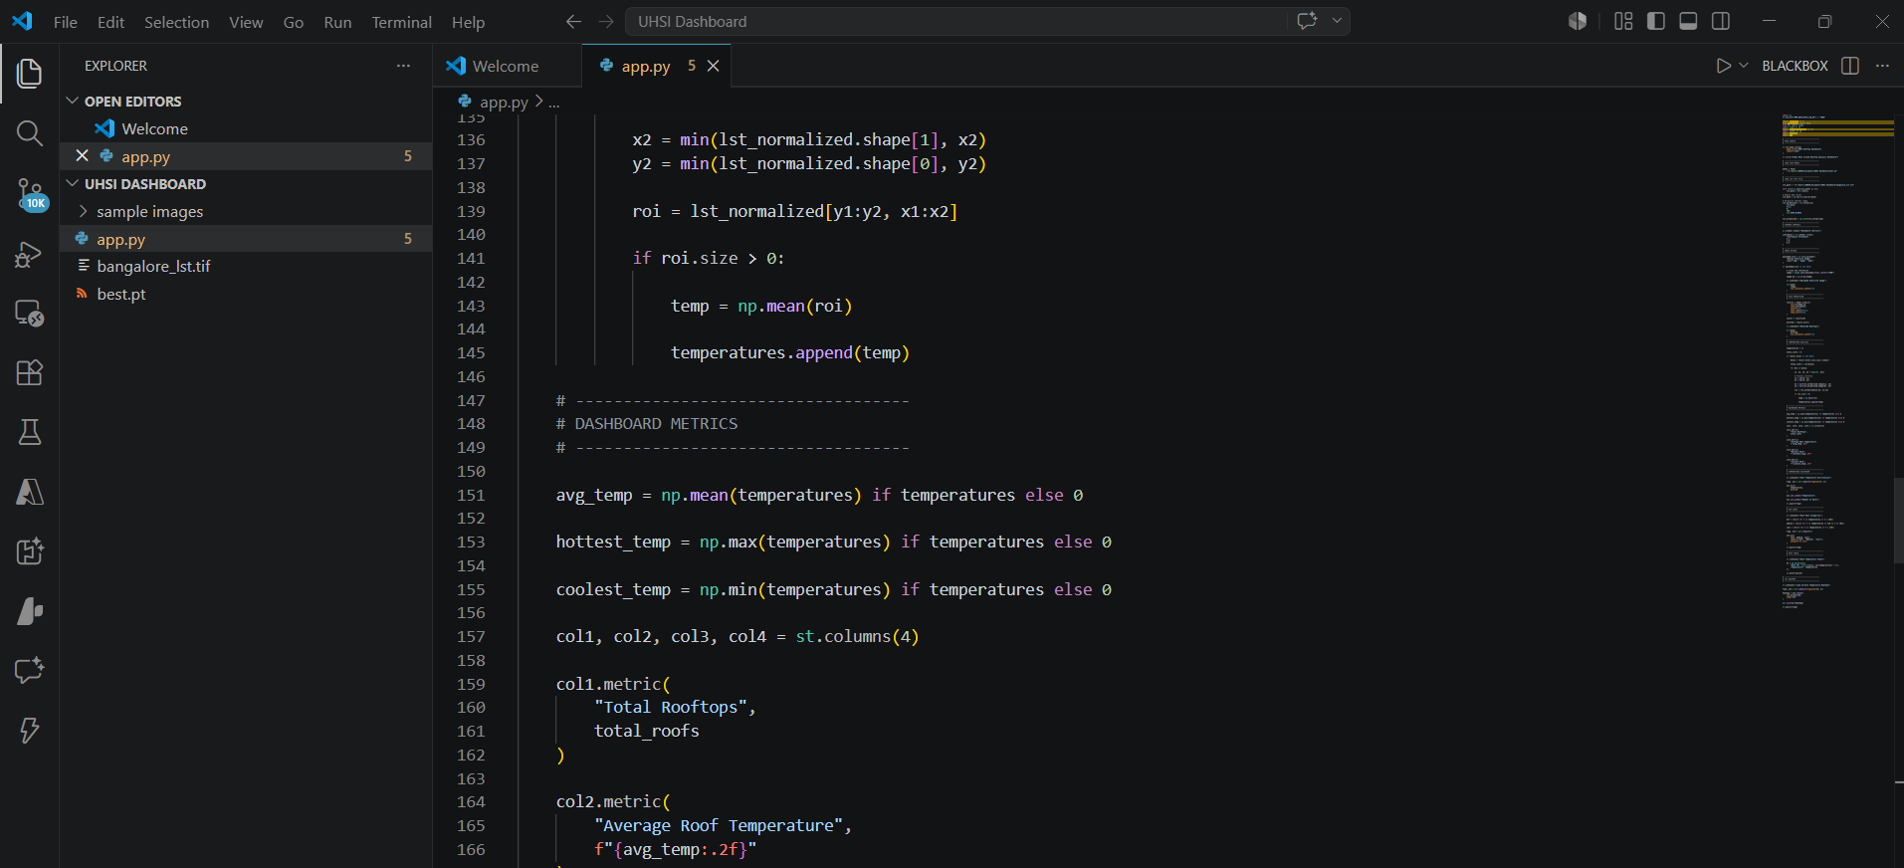
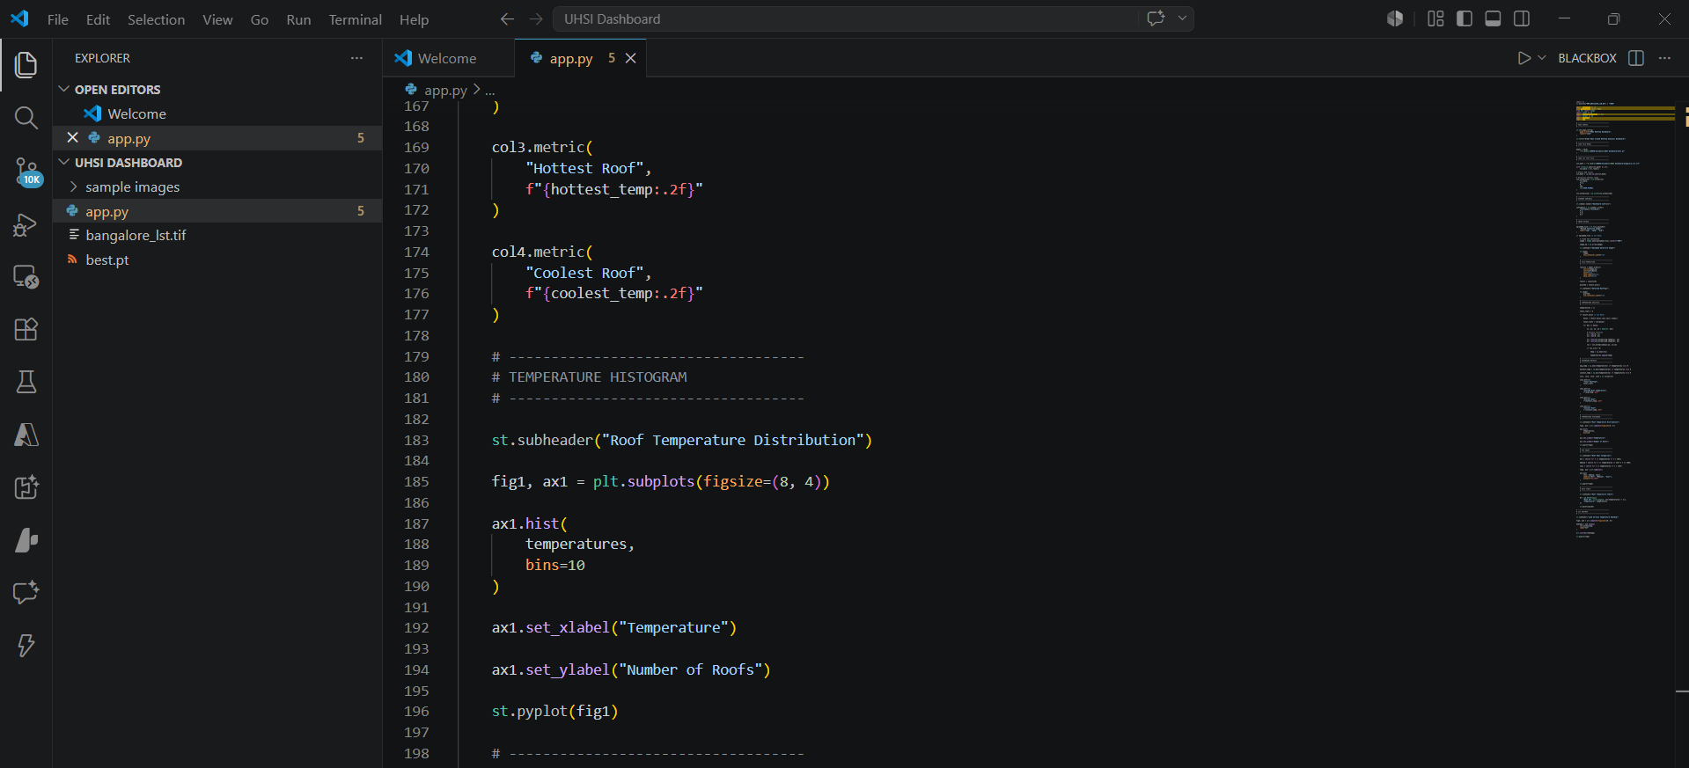
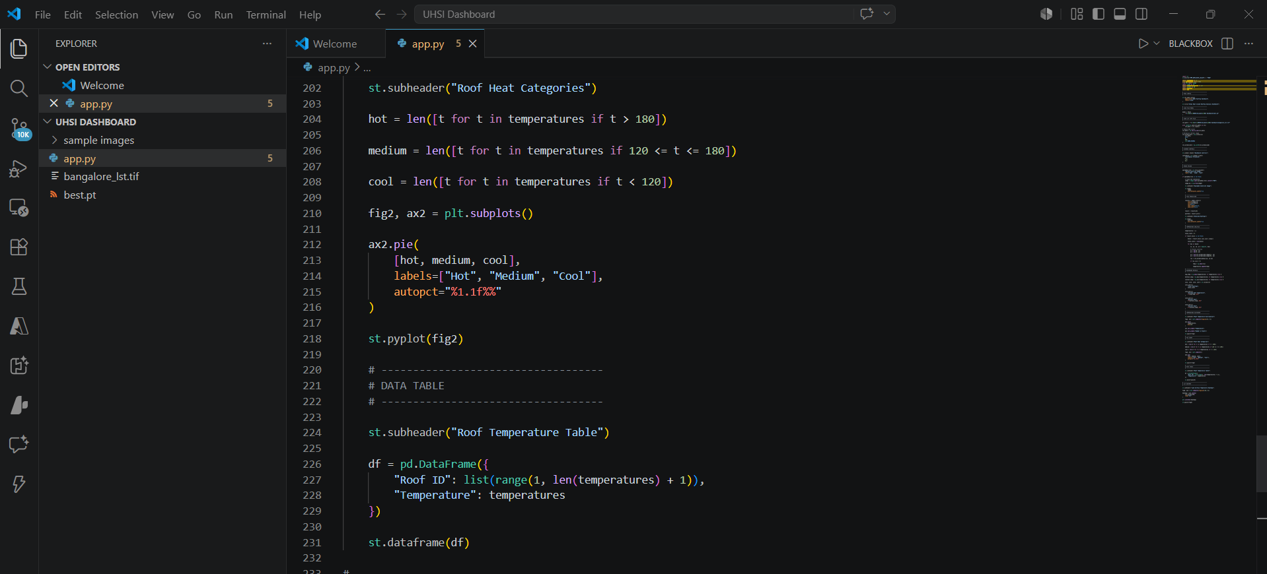
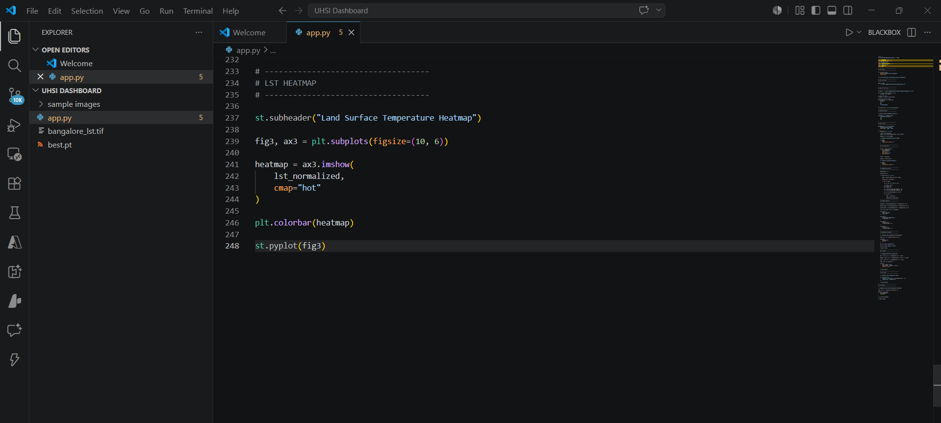

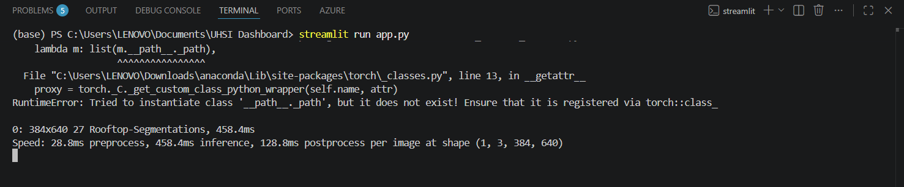

OUTPUTS:
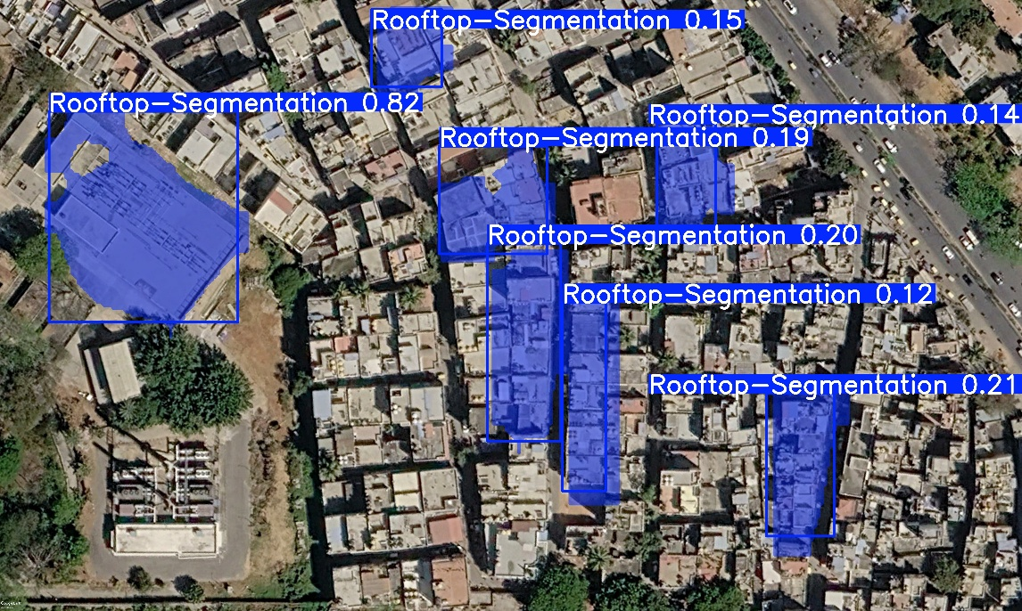
YOLOv8 Rooftop Segmentation Output

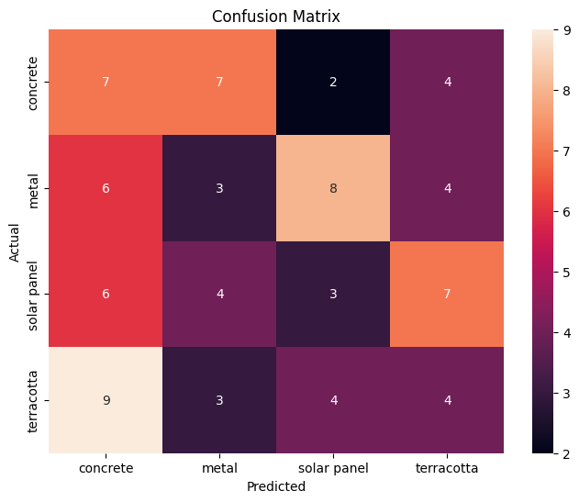
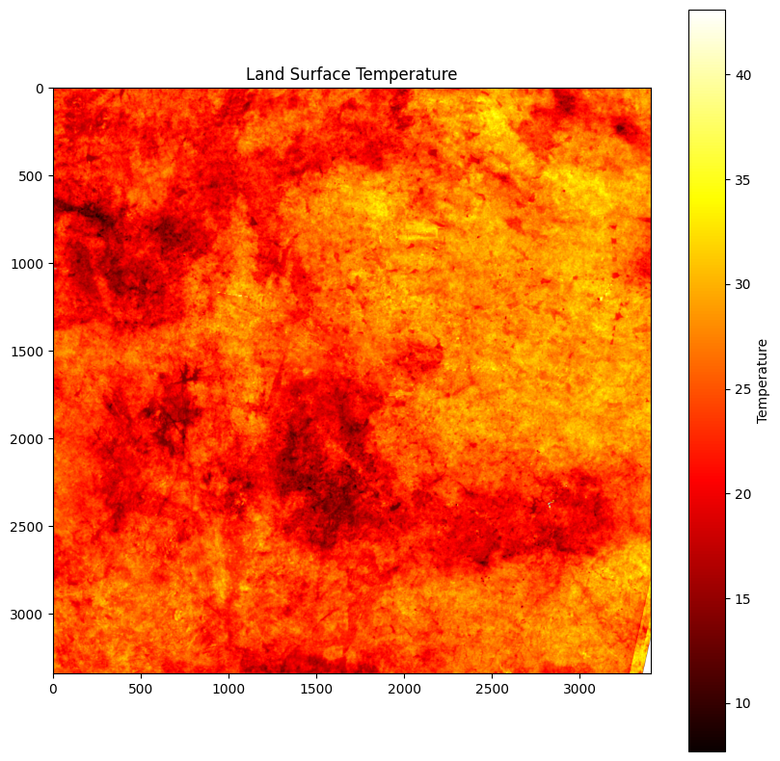
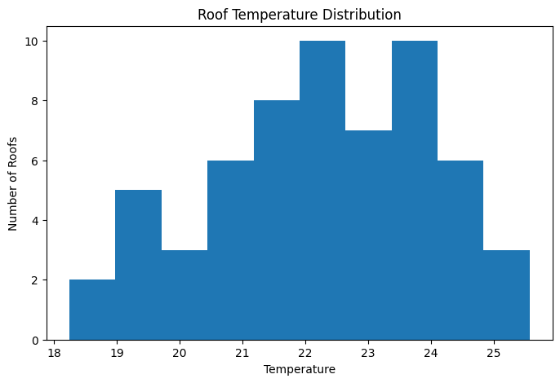

UHSI DASHBOARD OUTPUTS:

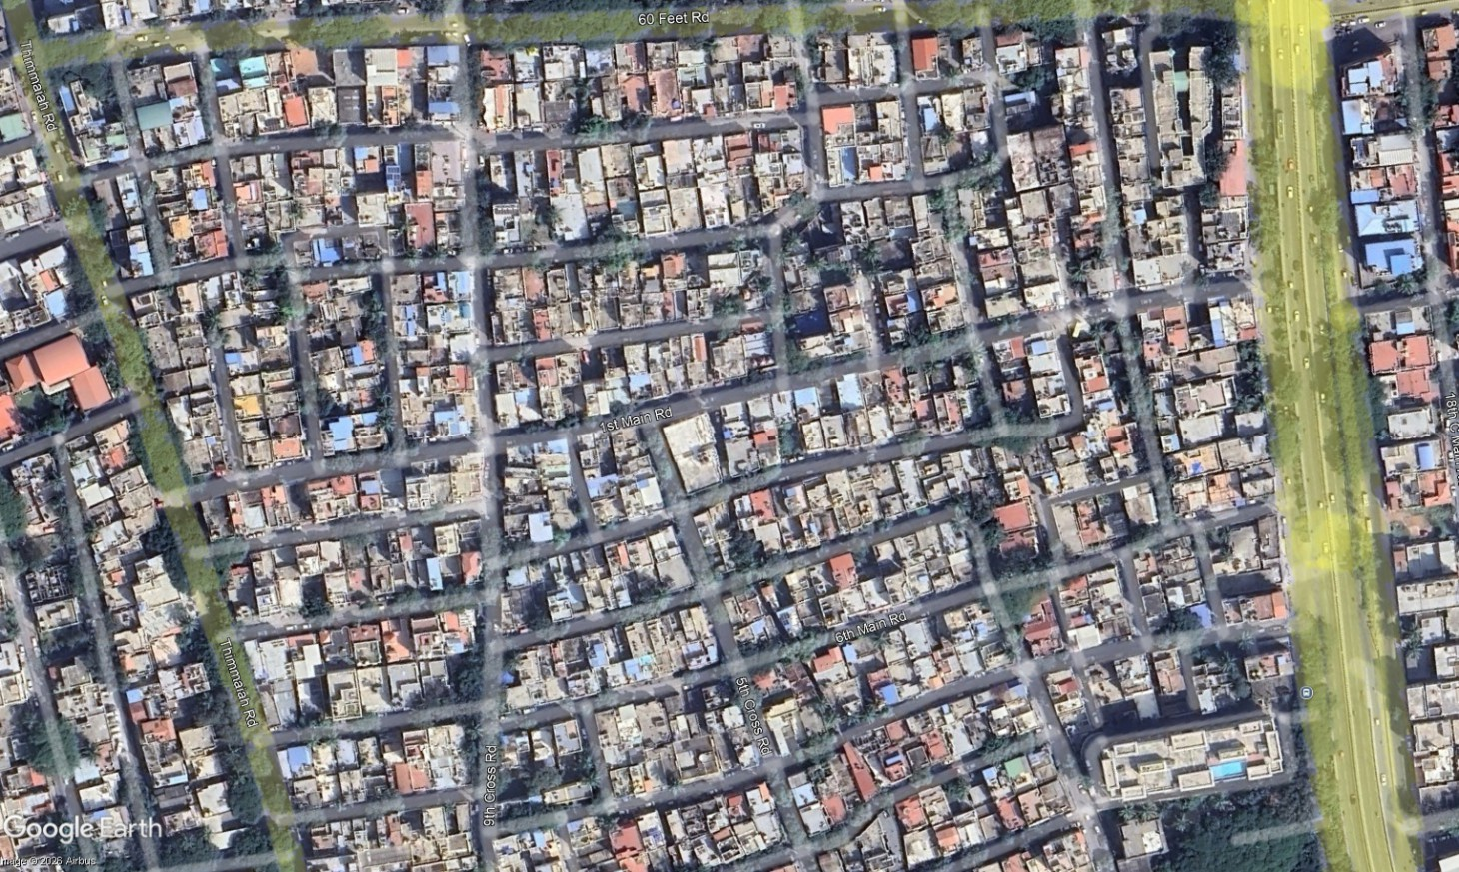
Uploaded Satellite Image
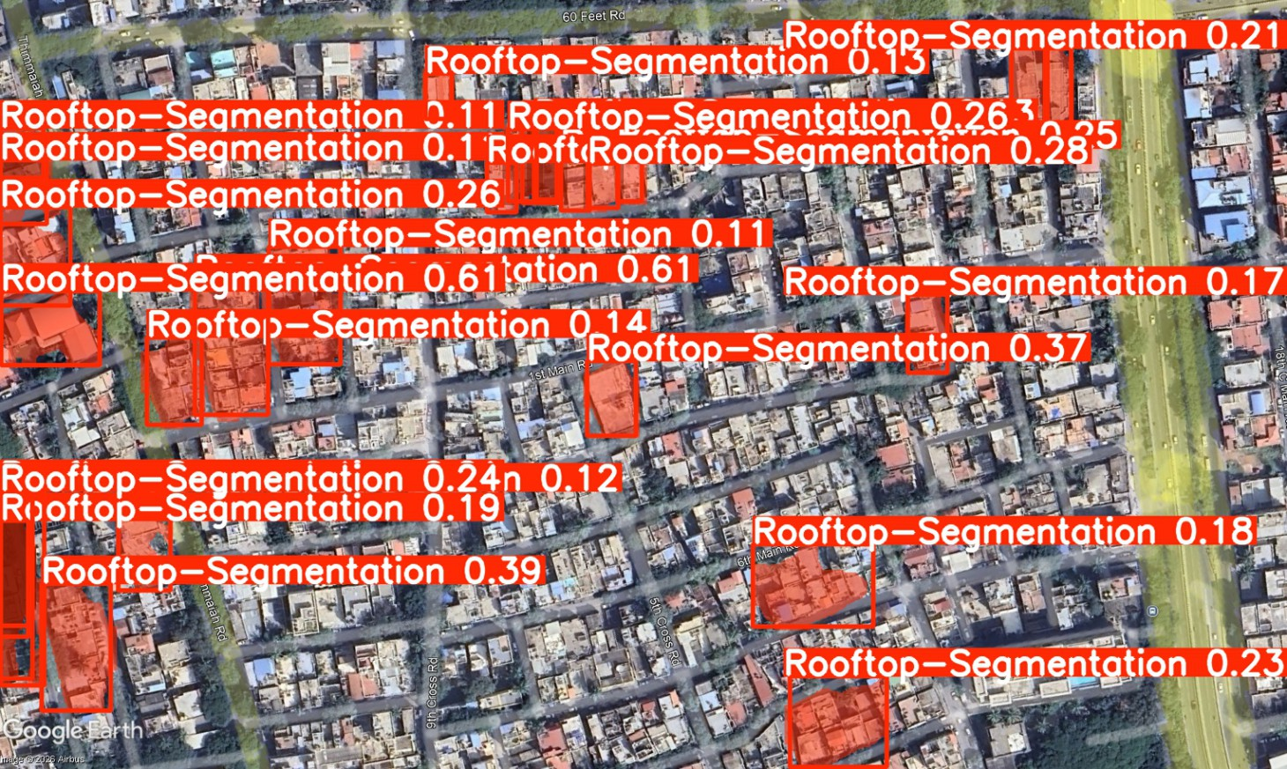
Detected Rooftops
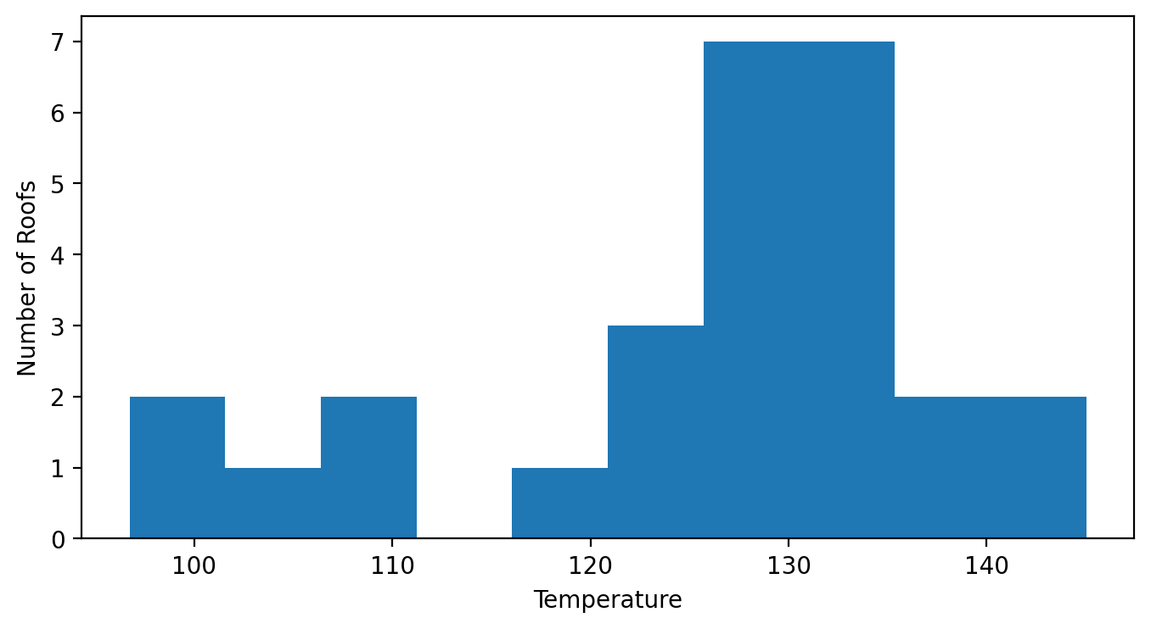
Roof Temperature Distribution
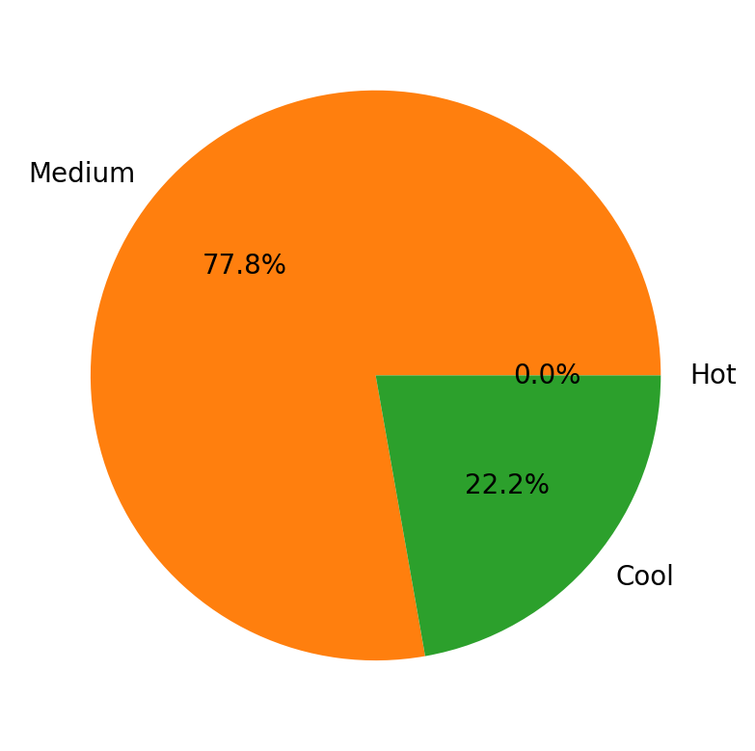
Roof Heat Categories

